LC–HRMS-Guided Network Pharmacology Reveals PARP1-Targeting Phytochemicals from Zanthoxylum acanthopodium with Anti-Melanoma Activity

Linda Chiuman ^{1,a*}; Dewi Purnama ²; Chrismis Novalinda Ginting ¹; Ermi Girsang ¹; Hariyadi Dharmawan Syahputra ³; Iksen Iksen ⁴

¹ Department of Medicine, Universitas Prima Indonesia, Medan-20118 (Indonesia)
² Doctoral Programme of Medicine, Universitas Prima Indonesia, Medan-20118 (Indonesia)
³ Department of Clinical Pharmacy, Universitas Prima Indonesia, Medan 20118, Medan-20118 (Indonesia)
⁴ Department of Pharmacy, Universitas Senior Medan, Medan-20141 (Indonesia)
^{a)}Correspondence: lindachiuman@unprimdn.ac.id
^{b} dewiqiuxia@gmail.com
^{c} chrismis@unprimdn.ac.id
^{d} ermigirsan9@unprimdn.ac.id
^{e} dharmawanhariyadi@gmail.com
^{f} ikseniksen08@gmail.com

ORCIDs:
Linda Chiuman : https://orcid.org/0000-0003-4822-0099
Dewi Purnama : https://orcid.org/0009-0001-7227-3230
Chrismis Novalinda Ginting : https://orcid.org/0000-0003-2269-2717
Ermi Girsang : https://orcid.org/0000-0003-4313-4941
Hariyadi Dharmawan Syahputra : https://orcid.org/0000-0003-1090-8859
Iksen Iksen : https://orcid.org/0000-0003-0166-4792

ACKNOWLEDGEMENT

This research supported by the Universitas Prima Indonesia and Universitas Senior Medan.

AUTHOR CONTRIBUTIONS

Conceptualization, L. C. and I. I.; Methodology, Validation, Resources, Data Curation, Writing – Original Draft Preparation, Funding Acquisition, L. C., D. P., H. D. S., and I. I.; Software, I. I.; Formal Analysis, Investigation, L. C., D. P., C. N. G., E. G., H. D. S., and I. I.; Writing – Review & Editing, L. C., H. D. S., and I. I.; Visualization, Supervision, L. C. and I. I.; Project Administration, L. C., and H. D. S.

CONFLICT OF INTEREST

The authors declare no conflict of interest.
DECLARATION OF GENERATIVE AI AND AI-ASSISTED TECHNOLOGIES IN THE MANUSCRIPT PREPARATION

Not applicable.

Supplementary Figure

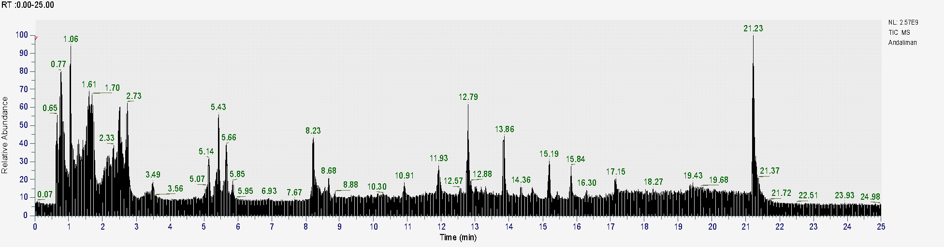
Figure S1. Total ion chromatogram of the ZA ethanolic extract obtained by LC–HRMS.

Table S1. Predicted physicochemical and pharmacokinetic properties of prioritized metabolites (M1–M12) identified from the ZA ethanolic extract.
No | Name | H-bond acceptors | H-bond donors | Log P | GI absorption | BBB permeant | Pgp substrate | CYP1A2 inhibitor | CYP2C19 inhibitor | CYP2C9 inhibitor | CYP2D6 inhibitor | CYP3A4 inhibitor | log Kp (cm/s) | Bioavailability Score
M1 | Kinsenoside | 8 | 4 | 0.58 | Low | No | Yes | No | No | No | No | No | -9.89 | 0.55
M2 | Taxa-4(20)_11(12)-dien-5alpha-ol | 1 | 1 | 3.35 | High | Yes | No | No | Yes | Yes | No | No | -4.9 | 0.55
M3 | 1_2-Bis(3_4-dimethoxyphenyl)propane-1_3-diol | 6 | 2 | 3.19 | High | No | Yes | No | No | No | Yes | Yes | -6.99 | 0.55
M4 | Laurixamine | 2 | 1 | 4.2 | High | Yes | No | Yes | No | No | Yes | No | -4.18 | 0.55
M5 | (−)-α-Cedrene | 0 | 0 | 3.2 | Low | No | No | No | Yes | Yes | No | No | -4.27 | 0.55
M6 | Certonardosterol J | 4 | 4 | 3.94 | High | No | Yes | No | No | No | No | No | -5.18 | 0.55
M7 | Beta-sanshool | 1 | 1 | 3.68 | High | Yes | No | No | No | Yes | No | No | -4.82 | 0.55
M8 | Capsi-amide | 1 | 1 | 4.31 | High | Yes | No | Yes | No | No | No | No | -3.36 | 0.55
M9 | Excavatolide M | 10 | 3 | 3.09 | Low | No | Yes | No | No | No | No | No | -9.11 | 0.55
M10 | Conicasterol B | 1 | 1 | 4.97 | Low | No | No | No | No | Yes | No | No | -3.8 | 0.55
M11 | 9-hydroxy-2,10,10-trimethyltricyclo[6.3.0.0Âa,âµ]undec-6-ene-6-carboxylic acid | 3 | 2 | 2.22 | High | Yes | No | No | No | No | No | No | -5.92 | 0.55
M12 | 3_4'_5-Trihydroxystilbene | 3 | 3 | 1.71 | High | Yes | No | Yes | No | Yes | No | Yes | -5.47 | 0.55

