Supporting Information

New Pyrrole-Chalcone Hybrids Against Acetylcholinesterase: Synthesis, In Vitro, and Computational Studies

Dadan Ridwanuloh ^{1,4,b)}, Ade Danova ^{2,c)}, Elvira Hermawati ^{2,d)}, Warinthorn Chavasiri ^{5,e)}, Ihsanawati Ihsanawati ^{3,f)}, Anita Alni ^{2,a*)}
¹ Doctoral Program of Chemistry, Institut Teknologi Bandung, Bandung-40132 (Indonesia)
² Organic Chemistry Division, Department of Chemistry, Institut Teknologi Bandung, Bandung-40132 (Indonesia)
³ Biochemistry and Biomolecular Engineering Research Division, Department of Chemistry, Institut Teknologi Bandung, Bandung-40132 (Indonesia)
⁴ Pharmacy Department, Universitas Buana Perjuangan Karawang, Karawang-41361 (Indonesia)
⁵ Center of Excellence in Natural Products Chemistry, Department of Chemistry, Chulalongkorn University, Bangkok-10330 (Thailand)
^{a)}Correspondence: alni@itb.ac.id
^{b)} 30521009@mahasiswa.itb.ac.id
^{c)} adedanova@itb.ac.id
^{d)} elvira.hermawati@itb.ac.id
^{e)} warinthorn.c@chula.ac.th
^{f)}ihsanawati@itb.ac.id

ORCIDs:
First AUTHOR : https://orcid.org/0000-0002-4781-7339
Second AUTHOR : https://orcid.org/0000-0003-4716-1170
Third AUTHOR : https://orcid.org/0000-0002-5492-3316
Fourth AUTHOR : https://orcid.org/0000-0001-5201-1324
Fifth AUTHOR : https://orcid.org/0000-0002-5784-762X
Sixth AUTHOR : https://orcid.org/0000-0002-2849-1919

ACKNOWLEDGEMENT

The first author acknowledges the doctoral scholarship support from the Center for Higher Education Funding and Assessment, Ministry of Higher Education, Science, and Technology, Republic of Indonesia, and the Indonesia Endowment Fund for Education (LPDP) through the Beasiswa Pendidikan Indonesia (BPI) program under grant number 202101120924 (0674/J5.2.3/BPI.06/10/2021). The authors also extend their appreciation to the ITB Integrated Chemistry Laboratory for providing access to NMR spectroscopy and mass spectrometry facilities. Special thanks are given in memory of the late Prof. Yana Maolana Syah for his invaluable guidance, advice, and support throughout the course of this study.
AUTHOR CONTRIBUTIONS

Conceptualization, Methodology, Formal Analysis, Investigation, and Data Curation, D. R. and A. D.; Software, Validation, and Resources, A. D. and E. H.; Writing – Original Draft Preparation, Visualization, and Funding Acquisition, D. R.; Writing – Review & Editing, D. R., A. D., E. H., W. C., I. I., and A. A.; Supervision, A. D., E. H., I. I., and A. A.; Project Administration, A. D. and E. H.

CONFLICT OF INTEREST

The authors declare no conflict of interest. The funding sponsor had no role in the selection of the research topic, study design, data collection, analysis or interpretation, manuscript writing, or in the decision to publish the results.

DECLARATION OF GENERATIVE AI AND AI-ASSISTED TECHNOLOGIES IN THE MANUSCRIPT PREPARATION

In the preparation of this manuscript, the authors affirm that no generative AI tools were used to generate or analyze any scientific content, data, or results. However, language editing and grammar improvements were conducted with the assistance of generative AI technologies (e.g., ChatGPT by OpenAI) under the full supervision and control of the authors. All content, scientific interpretations, analyses, and conclusions remain entirely the responsibility of the authors. The AI tools were not used to write original scientific content or draw conclusions, and they are not listed as authors or contributors. The use of such tools complies with ethical standards and transparency requirements of the Journal of Multidisciplinary Applied Natural Science.

¹H NMR (500 MHz, DMSO-d₆) compound 2
¹³C NMR (125 MHz, DMSO-d₆) compound 2

HRMS spectrum of compound 2
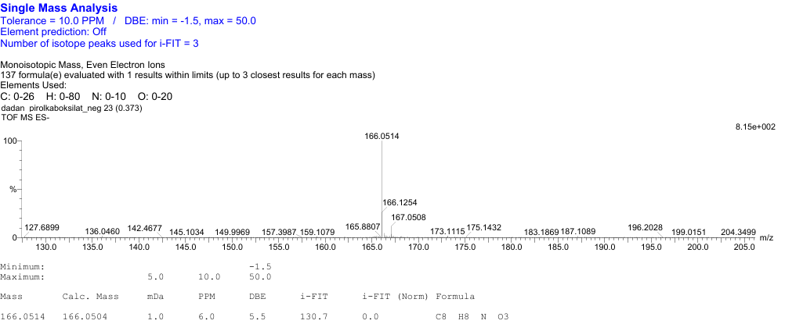

¹H NMR (500 MHz, DMSO-d₆) compound 3
¹³C NMR (125 MHz, DMSO-d₆) compound 3
HRMS spectrum of compound 3
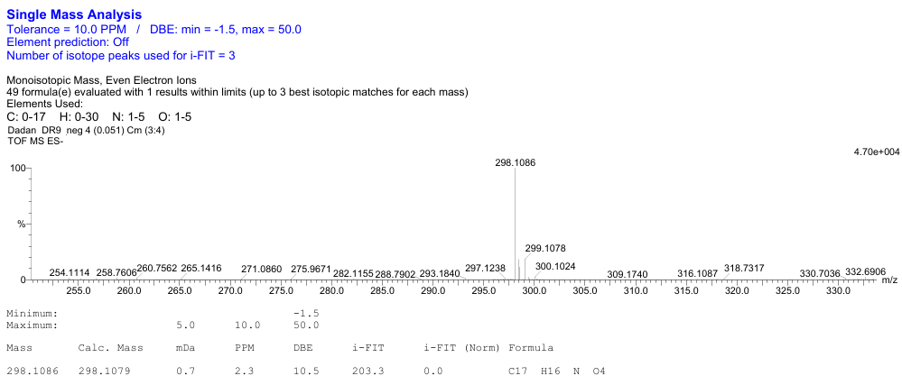

¹H NMR (500 MHz, DMSO-d₆) compound 4
¹³C NMR (125 MHz, DMSO-d₆) compound 4
HRMS spectrum of compound 4
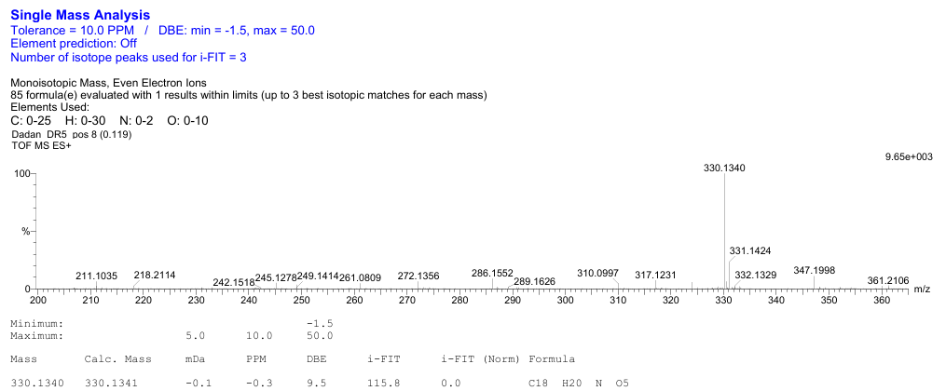

¹H NMR (500 MHz, DMSO-d₆) compound 5
¹³C NMR (125 MHz, DMSO-d₆) compound 5
HRMS spectrum of compound 5
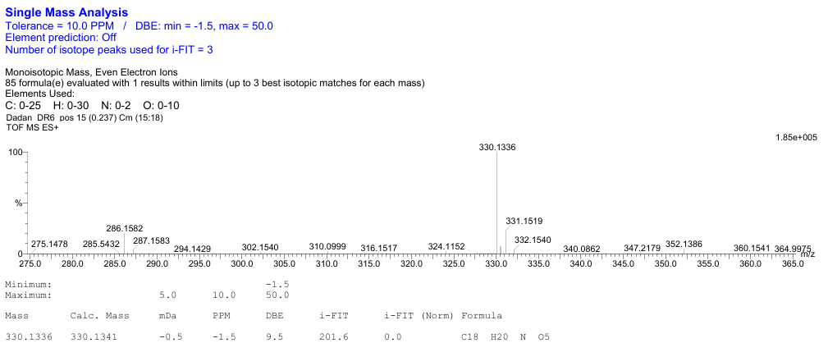

¹H NMR (500 MHz, DMSO-d₆) compound 6
¹³C NMR (125 MHz, DMSO--d6) compound 6
HRMS spectrum of compound 6
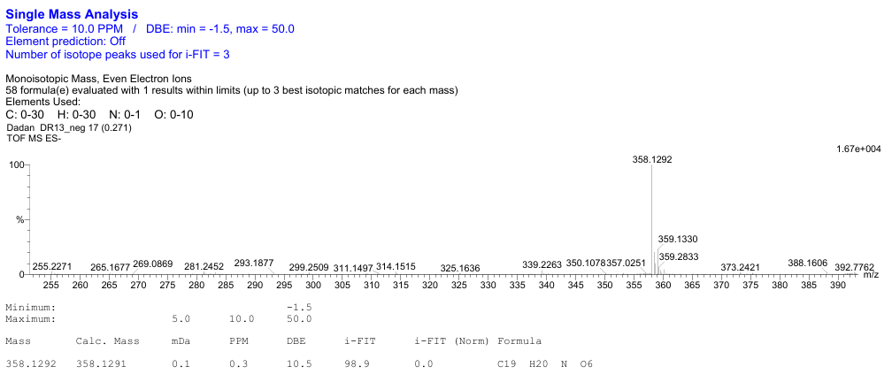

¹H NMR (500 MHz, DMSO-d₆) compound 7
¹³C NMR (125 MHz, DMSO-d₆) compound 7
¹H NMR (500 MHz, DMSO-d₆) compound 8
¹³C NMR (125 MHz, DMSO-d₆) compound 8
HRMS spectrum of compound 8
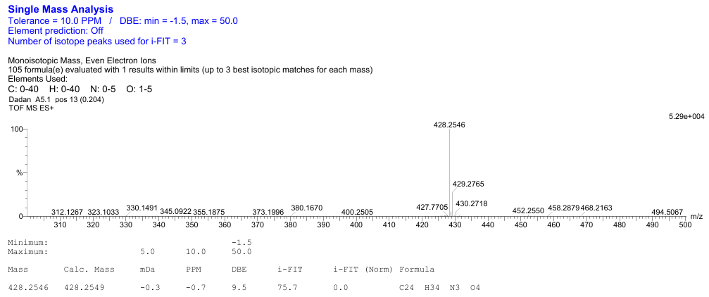

¹H NMR (500 MHz, Acetone-d₆) compound 9
¹³C NMR (125 MHz, Acetone-d₆) compound 9
HRMS spectrum of compound 9

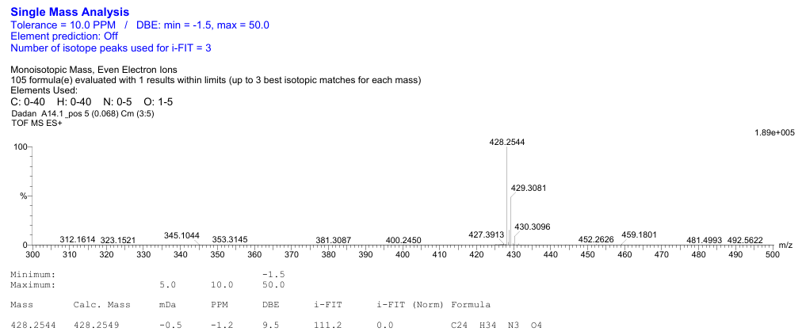

¹H NMR (500 MHz, DMSO-d₆) compound 10
¹³C NMR (125 MHz, DMSO-d₆) compound 10
HRMS spectrum of compound 10

