Support Information

Modulation of AR-FGF-2-TGF beta Axis by Cosmos caudatus Suppresses Prostatic Epithelial Proliferation in a BPH Rat Model: A Comparative Study with Finasteride

Nita Sahara ^{1,2a*)}; Ambar Mudigdo ^{1,3b)}; Brian Wasita ^{1,3c)}; Eti Poncorini Pamungkasari ^{1,4d)}; Paramasari Dirgahayu ^{1,5e)}; Risya Cilmiaty ^{1,6f)}

¹ Doctoral Program of Medical Science, Universitas Sebelas Maret, Surakarta -57126 (Indonesia)
² Departement of Anatomical Pathology, Universitas Malahayati, Bandar Lampung-35152 (Indonesia)
³ Department of Anatomical Pathology, Universitas Sebelas Maret, Surakarta -57126 (Indonesia)
⁴ Department of Public Health, Universitas Sebelas Maret, Surakarta-57126 (Indonesia)
⁵ Departement of Parasitology and Mycology, Universitas Sebelas Maret, Surakarta-57126 (Indonesia)
⁶ Departement of Oral Disease, Universitas Sebelas Maret, Surakarta-57126 (Indonesia)
^{a)}Correspondence: nitasahara.ns@malahayati.ac.id
^{b)}brianwasita@staff.uns.ac.id
^{c)}etiponco@staff.uns.ac.id
^{d)}paramasari_d@staff.uns.ac.id
^{e)}risyacilmiaty@staff.uns.ac.id

ORCIDs:
Nita Sahara : https://orcid.org/0000-0002-9513-8410
Ambar Mudigdo : https://orcid.org/0009-0006-8215-8742
Brian Wasita : https://orcid.org/0000-0002-5501-3541
Eti Poncorini P : https://orcid.org/0000-0002-4197-3226
Paramasari Dirgahayu : https://orcid.org/0000-0002-8384-8693
Risya Cilmiaty : https://orcid.org/0000-0001-9351-5246

ACKNOWLEDGEMENT

This research was supported by the Indonesian Education Scholarship Program (BPI) Through the Center for Higher Education Funding and Assessment (PPAPT), Ministry of Higher Education Science, and Technology of the Republik Indonesia and The Indonesia Endowment Fund for Education (LPDP) [ 00338/J5.2.3./BPI.06/9/2022].

AUTHOR CONTRIBUTIONS

N. S. designed the study, performed the investigation and data analysis, and wrote the original draft. A. M., B. W., E. P. P., P. D., and R. C. provided supervision, contributed to the conceptualization, and critically reviewed and edited the manuscript. All authors have read and agreed to the published version of the manuscript.
CONFLICT OF INTEREST

The authors declare no conflict of interest.

DECLARATION OF GENERATIVE AI AND AI-ASSISTED TECHNOLOGIES IN THE MANUSCRIPT PREPARATION

Not applicable.

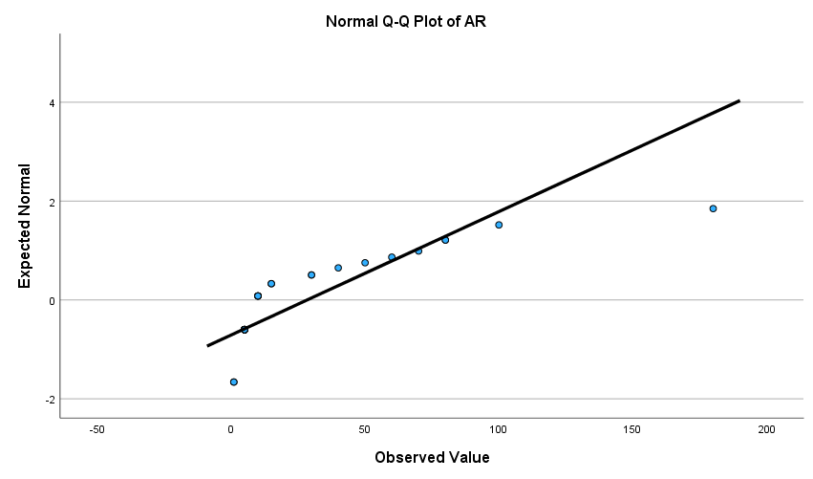
Figure S1. Normal Q-Q Plot of AR.

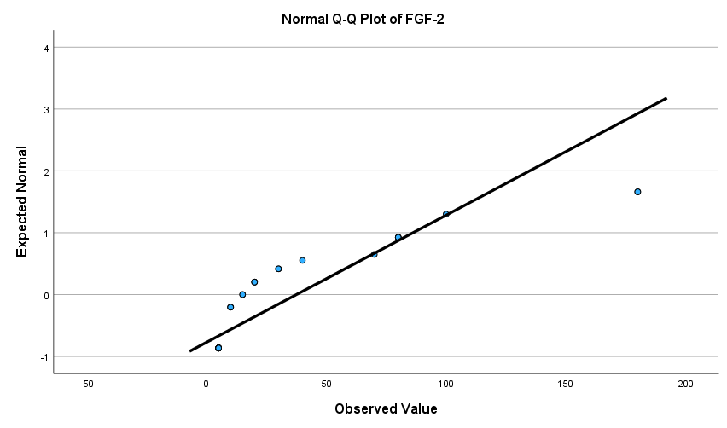
Figure S2. Normal Q-Q Plot of FGF-2

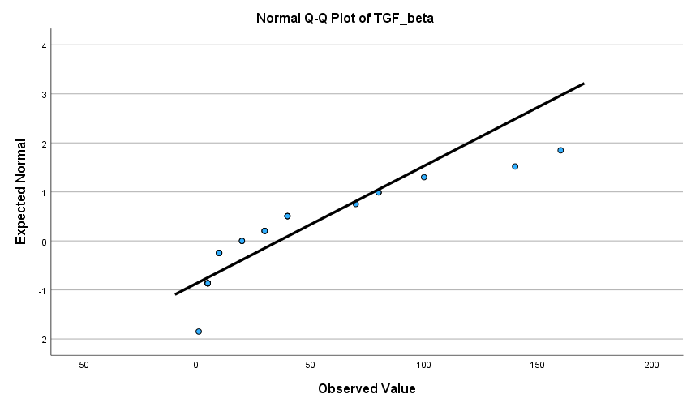
Figure S3. Normal Q-Q Plot of TGF-β.

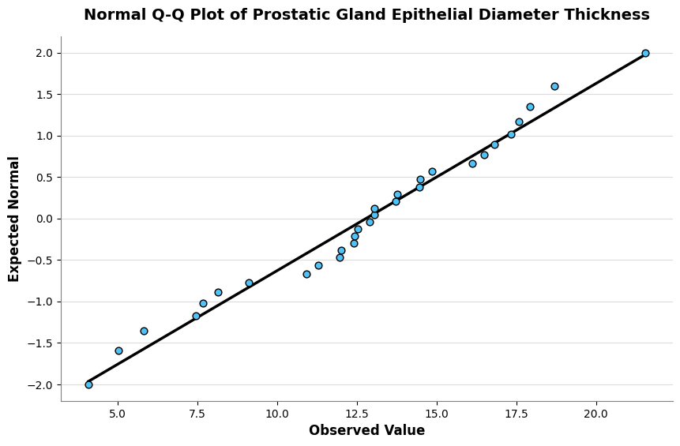
Figure S4. Normal Q-Q Plot of Prostatic Gland Epithelial Diameter Thickness.
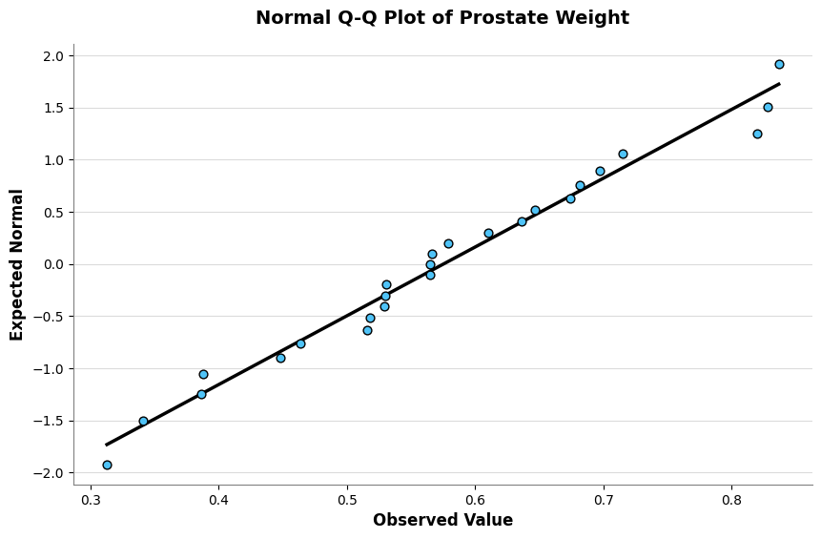
Figure S5. Normal Q-Q Plot of Prostate Weight.

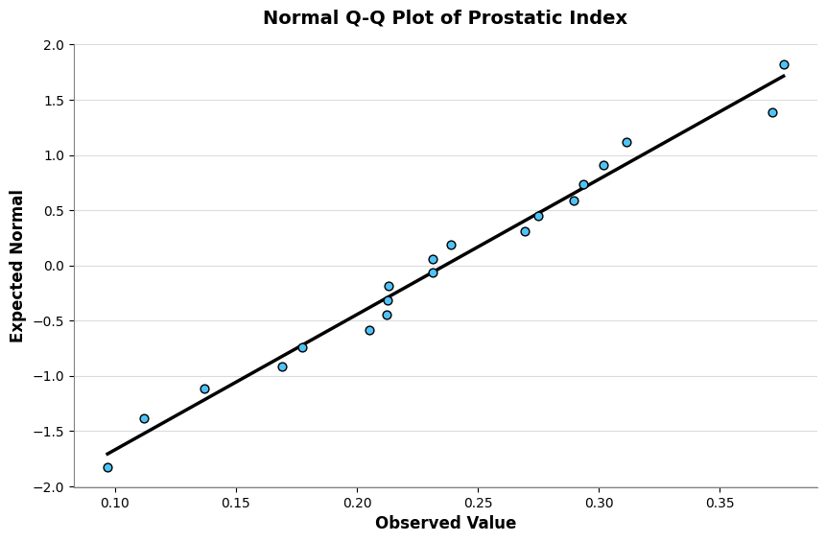
Figure S6. Normal Q-Q Plot of Prostatic Index

\
Table S1. Parametric Outcome (Epithelial Thickness).
Variable | Statistic | Interpretation
Epithelial Thickness | η² = 0.667 | Large effect

Table S2. AR Expression (Mann–Whitney, r = Z / √N).
Comparison | Z | r | Interpretation
N vs KN | –2.478 | 0.716 | Large
N vs P2 | –2.994 | 0.865 | Large
KN vs KP | –2.329 | 0.673 | Large
KN vs P1 | –2.347 | 0.677 | Large
KP vs P2 | –2.945 | 0.850 | Large
P1 vs P2 | –2.898 | 0.836 | Large

Table S3. FGF-2 Expression.
Comparison | Z | r | Interpretation
N vs KN | –2.939 | 0.848 | Large
N vs P2 | –2.342 | 0.676 | Large
KN vs KP | –2.913 | 0.841 | Large
KN vs P1 | –2.115 | 0.611 | Large
KP vs P2 | –2.221 | 0.641 | Large

Table S4. TGF-β Expression.
Comparison | Z | r | Interpretation
N vs KN | –2.697 | 0.779 | Large
N vs P2 | –2.844 | 0.821 | Large
KN vs KP | –2.608 | 0.753 | Large
KN vs P2 | –2.115 | 0.611 | Large
KP vs P2 | –2.837 | 0.819 | Large

Table S5. Prostate Weight.
Comparison | Z | r | Interpretation
N vs KN | –2.246 | 0.648 | Large
N vs KP | –2.085 | 0.602 | Large
KN vs KP | –2.242 | 0.647 | Large
KN vs P2 | –2.242 | 0.647 | Large
Table S6. Prostate Index.
Comparison | Z | r | Interpretation
N vs KN | –2.266 | 0.654 | Large
N vs KP | –2.027 | 0.585 | Large
KN vs KP | –2.250 | 0.650 | Large
KN vs P2 | –2.746 | 0.793 | Large

