Support Information

Integrative Multi-Omics and Experimental Approaches Identify SRC as a Central Target of Garcinia atroviridis Flavonoids in Lung Cancer

Iksen Iksen^{1,a*}; Fani Nuryana Manihuruk²; Hariyadi Dharmawan Syahputra³; Mazmuranda Saragih¹; Ivan Eben Ezer Manurung¹; Ruth Sari Uni Peranginangin¹; Dea Febrince Putri Saragih¹; Helen Anjelina Simanjuntak¹; Kasta Gurning¹

¹Department of Pharmacy, Sekolah Tinggi Ilmu Kesehatan Senior Medan, Medan-20141 (Indonesia)
²Department of Health Analyst, Sekolah Tinggi Ilmu Kesehatan Senior Medan, Medan-20141 (Indonesia)
³Faculty of Medicine, Dentistry and Health Science, Universitas Prima Indonesia, Medan-20118 (Indonesia)
^{a)}Correspondence: ikseniksen08@gmail.com

ORCIDs:
Iksen Iksen : https://orcid.org/0000-0003-0166-4792
Fani Nuryana Manihuruk : https://orcid.org/0009-0002-7014-3974
Hariyadi Dharmawan Syahputra : https://orcid.org/0000-0003-1090-8859
Mazmuranda Saragih : https://orcid.org/0009-0006-9118-0423
Ivan Eben Ezer Manurung : https://orcid.org/0009-0004-0634-1110
Ruth Sari Uni Peranginangin : https://orcid.org/0009-0005-4463-4114
Dea Febrince Putri Saragih : https://orcid.org/0009-0006-0020-5489
Helen Anjelina Simanjuntak : https://orcid.org/0000-0001-7151-5464
Kasta Gurning : https://orcid.org/0000-0002-0676-0030

ACKNOWLEDGEMENT

This research was supported by the Directorate of Research and Community Service, Directorate General of Research and Development, Ministry of Higher Education, Science, and Technology of the Republic of Indonesia, through the Regular Fundamental Research Grant (Year 2025, Contract No. 003/LPPM/STIKes-SENIOR/VI/2025).

AUTHOR CONTRIBUTIONS

Conceptualization, Software, Resources, Visualization, Supervision, Funding Acquisition, and Writing – Review & Editing, I. I.; Methodology, Validation, Formal Analysis, Data Curation, Writing – Original Draft Preparation, Project Administration, I. I., F. N. M., and H. D. S.; Investigation, I. I., F. N. M., H. D. S. M. S., I. E. E. M., R. S. U. P., D. F. P. S., H. A. S., and K. G.

CONFLICT OF INTEREST

The authors declare no conflict of interest.

DECLARATION OF GENERATIVE AI AND AI-ASSISTED TECHNOLOGIES IN THE MANUSCRIPT PREPARATION

Not applicable.

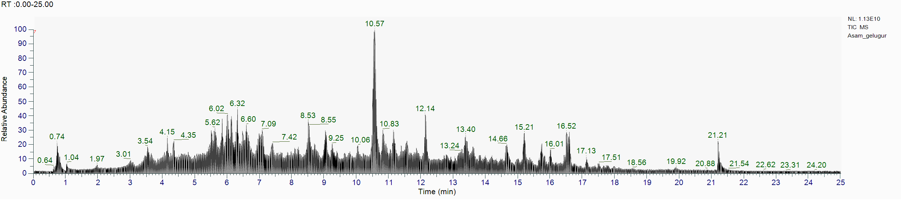
Figure S1. Total ion chromatogram (TIC) of the ethanolic extract of Garcinia atroviridis obtained by LC-HRMS, showing the distribution of major phytoconstituents.
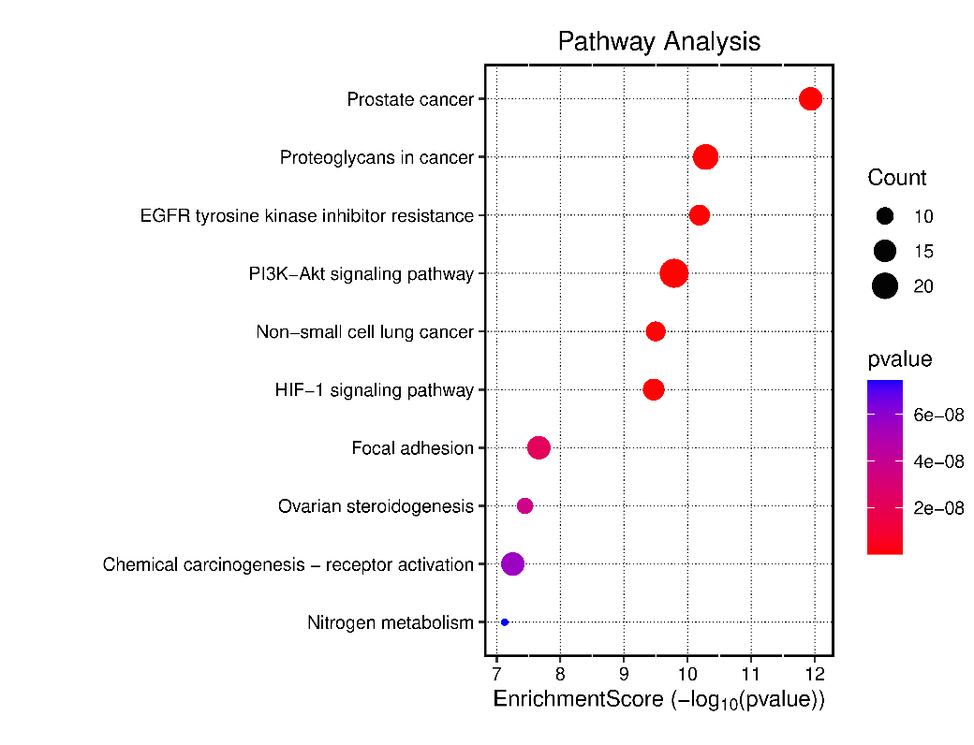
Figure S2. KEGG pathway enrichment analysis of the 142 overlapping targets derived from GA flavonoid prediction and lung cancer–associated genes. The dot plot shows the top enriched KEGG pathways ranked by enrichment score. Dot size represents the number of genes involved in each pathway, and dot color indicates the adjusted p-value (Benjamini–Hochberg FDR). Pathways with FDR < 0.05 were considered significantly enriched.

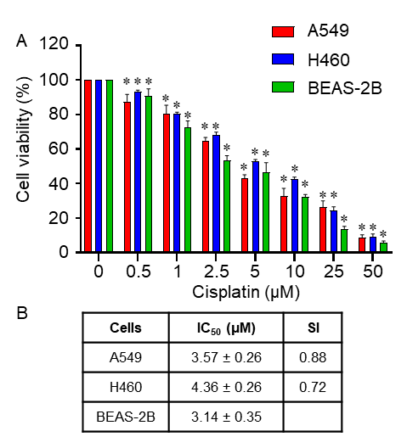
Figure S3. Cytotoxic effect of cisplatin on lung cancer and normal lung epithelial cells. (A) Cell viability of A549, H460, and BEAS-2B cells treated with increasing concentrations of cisplatin for 72 h, measured by MTT assay. (B) Calculated IC₅₀ values and selectivity index (SI) of cisplatin in each cell line. Data represent mean ± SEM of three independent biological replicates (n = 3), each performed with three technical replicates. Statistical significance was assessed using one-way ANOVA followed by Tukey’s post-hoc test, with *p < 0.05 versus control.

Table S1. Full ranked gene lists from GSE19188 (provided as separate Excel file).
Available on : 10.47352/jmans.2774-3047.344

Table S2. Top 100 upregulated and downregulated targets identified from GSE19188 (provided as separate Excel file).
Available on : 10.47352/jmans.2774-3047.344

