Support Information

Carbon Storage in Organic, Labile, and Mineral Forms across Irrigated Soils of the Beni Moussa Sub-Perimeter, Tadla Plain (Morocco)

Maria El-harram ^{1,a*)}; Mohamed El Baghdadi ^{1,b)}, El Hassania El Hamzaoui ^{1,c)}; Khadija Elyamany ^{1,d)}; Jamila Zouhri ^{1,e)}; Atika Mouaddine ^{1,f)}

¹ Department of Earth Sciences, Sultan Moulay Slimane University, Beni-Mellal-23000 (Morocco)

^{a)}Correspondence: maria.elharram@usms.ma
^{b)} M.ELBAGHDADI@usms.ma
^{c)} elhassania.elhamzaoui@usms.ma
^{d)} khadijayamani215@gmail.com
^{e)} jamilazouhri1@gmail.com
^{f)} mouaddineatika@gmail.com

ORCIDs:
First AUTHOR : https://orcid.org/0000-0002-3307-3834
Second AUTHOR : https://orcid.org/0000-0002-7654-5344
Third AUTHOR : https://orcid.org/0000-0002-7816-8554
Fourth AUTHOR : https://orcid.org/0009-0003-0183-7419
Fifth AUTHOR : https://orcid.org/0009-0000-0815-3552
Sixth AUTHOR : https://orcid.org/0009-0002-9668-1033

ACKNOWLEDGEMENT

This study was a part of a PhD thesis. We are deeply grateful to the staff of the Geomatics, Georesources and Environment Laboratory for their support throughout this work.

AUTHOR CONTRIBUTIONS

Conceptualization, M. E. -H. and M. E. -B.; Methodology, Software, Validation, Data Curation, Writing – Original Draft Preparation, and Writing – Review & Editing, M. E. -H. and E. H. E. H.; Formal Analysis, M. E. -H., E. H. E. H., and A. M.; Investigation, Resources, M. E. -H.; Visualization, M. E. -H., K. E., and J. Z.; Supervision, M. E. -B.; Project Administration, and Funding Acquisition, M. E. -H. and M. E. -B.

CONFLICT OF INTEREST

The authors declare no conflict of interest.

DECLARATION OF GENERATIVE AI AND AI-ASSISTED TECHNOLOGIES IN THE MANUSCRIPT PREPARATION

While preparing this work, the author(s) used ChatGPT (OpenAI) exclusively for language editing and grammar checks to enhance clarity and readability. The tool was not employed to create or alter scientific content, data, analyses, or conclusions. After utilizing the tool, the author(s) reviewed and made necessary edits and are fully responsible for the final content of the publication.

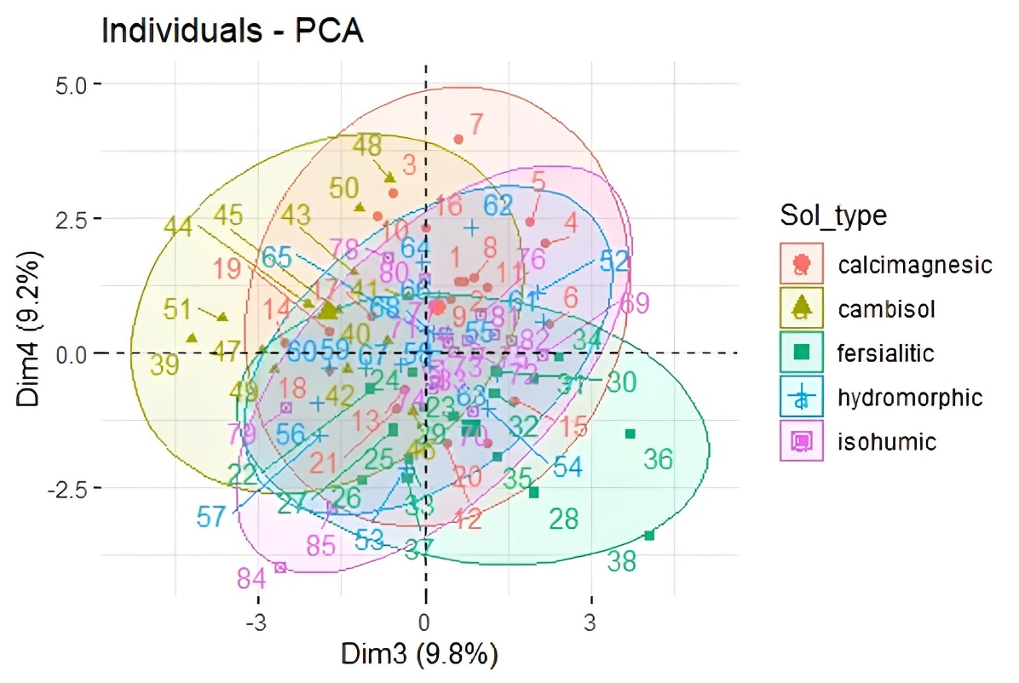
Figure S1. Individual factor map from PCA, showing the contribution and quality of representation (cos² values) of soil samples along Dim3 (9.8%) and Dim4 (9.2%).

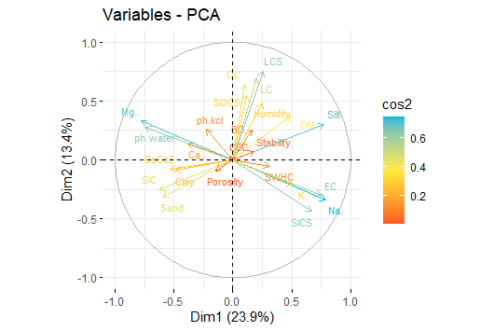
Figure S2. The cos² values of the variables on the Dim1–Dim2 plane.
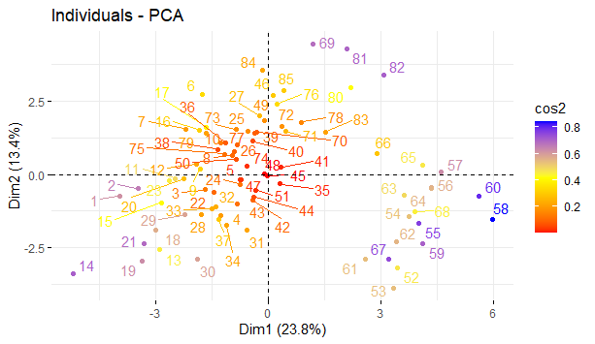
Figure S3. The cos² values of soil samples (individuals) on the Dim1–Dim2 plane.

