Support Information

Phytochemical, Antioxidant and Anticancer Properties of Ayusip (Vaccinium uliginosum L.) from Benguet Province, Philippines

Haniyah A. Dacsla ^{1,2)}; Al James A. Manua ³⁾; Rod Vincent E. Borromeo ³⁾; Ranelle Janine L. Asi ³⁾; Merrah Joy Subebe ¹⁾; Nanette Hope N. Sumaya ¹⁾; Michael Muhmin E. Manting ¹⁾; Ma. Reina Suzette B. Madamba ¹⁾; Jaime Q. Guihawan ⁴⁾; Isidro B. Arquisal ¹⁾; Carlito Baltazar Tabelin ⁵⁾; Arnel Beltran ⁶⁾; David Guilingen ⁶⁾; Jethro Guilingen ⁶⁾; Aileen H. Orbecido ⁶⁾; Michael Angelo Promentilla ⁶⁾; Marlon Suelto ⁷⁾; Dennis A. Alonzo ⁸⁾; Anne D. Jungblut ⁹⁾; Richard Herrington ⁹⁾; Javier Lozano-Gerona ³⁾; Ahmad Reza F. Mazahery ³⁾; Mylah Villacorte-Tabelin ^{1,10}*⁾

¹ Department of Biological Sciences, Mindanao State University-Iligan Institute of Technology, Iligan City-9200 (Philippines)
² Department of Biology, Mindanao State University-Main Campus, Marawi City-9700 (Philippines)
³ Institute of Biology, University of the Philippines, Quezon City-1101 (Philippines)
⁴ Department of Environmental Science, Mindanao State University-Iligan Institute of Technology, Iligan City-9200 (Philippines)
⁵ Department of Materials and Resources Engineering and Technology, Mindanao State University–Iligan Institute of Technology, Iligan City-9200 (Philippines)
⁶ Department of Chemical Engineering, De LaSalle University, Manila-1004 (Philippines)
⁷ University of the Philippines Los Baños, Laguna-4031 (Philippines)
⁸ School of Education, University of New South Wales, Sydney-2033 (Australia)
⁹ Department of Science, Natural History Museum, London-SW7 5BD (United Kingdom)
¹⁰ Center for Natural Products and Drug Discovery, Mindanao State University-Iligan Institute of Technology, Iligan City-9200 (Philippines)

haniyah.dacsla@g.msuiit.edu.ph
aljames.manua@g.msuiit.edu.ph
rlborromeo@up.edu.ph
rlasi@up.edu.ph
merrahjoy.subebe@g.msuiit.edu.ph
nanettehope.sumaya@g.msuiit.edu.ph
muhmin.manting@g.msuiit.edu.ph
suzette.madamba@g.msuiit.edu.ph
jaime.guihawan@g.msuiit.edu.ph
isidro.arquisal@g.msuiit.edu.ph
carlito.tabelin@g.msuiit.edu.ph
arnel.beltran@dlsu.edu.ph
dguilingen22@gmail.com
guilingenjethro@gmail.com
aileen.orbecido@dlsu.edu.ph
michael.promentilla@dlsu.edu.ph
msuelto@umindanao.edu.ph
d.alonzo@unsw.edu.au
a.jungblut@nhm.ac.uk
r.herrington@nhm.ac.uk
jlozano1@up.edu.ph
afmazahery@up.edu.ph
Corresponding author: mylah.tabelin@g.msuiit.edu.ph

ORCIDs:
Haniyah Dacsla : https://orcid.org/0009-0001-5508-2539
Al James A. Manua : https://orcid.org/0000-0001-9244-4714
Rod Vincent E. Borromeo : https://orcid.org/0009-0006-0520-4733
Ranelle Janine L. Asi : https://orcid.org/0009-0008-6015-0787
Merrah Joy Subebe : https://orcid.org/0009-0002-6509-6042
Nanette Hope Sumaya : https://orcid.org/0000-0002-2645-1120
Muhmin Michael E. Manting : https://orcid.org/0000-0003-2744-4165
Ma. Reina Suzette B. Madamba : https://orcid.org/0000-0003-1803-1334
Jaime Q. Guihawan : https://orcid.org/0000-0003-3485-3549
Isidro B. Arquisal : https://orcid.org/0009-0007-9982-8914
Carlito Baltazar Tabelin : https://orcid.org/0000-0001-8314-6344
Arnel Beltran : https://orcid.org/0000-0003-2764-6226
David Guilingen : https://orcid.org/0009-0008-3591-2997
Jethro Guilingen : https://orcid.org/0009-0009-1960-7439
Aileen H. Orbecido : https://orcid.org/0000-0003-3322-0539
Michael Angelo Promentilla : https://orcid.org/0000-0002-9009-8552
Marlon Suelto : https://orcid.org/0009-0001-6700-612X
Dennis A. Alonzo : https://orcid.org/0000-0001-8900-497X
Anne D. Jungblut : https://orcid.org/0000-0002-4569-8233
Richard Herrington : https://orcid.org/0000-0002-4569-8233
Javier Lozano-Gerona : https://orcid.org/0000-0003-4867-2511
Ahmad Reza F. Mazahery : https://orcid.org/0000-0001-5658-1498
Mylah Villacorte-Tabelin : https://orcid.org/0000-0002-6383-7049

ACKNOWLEDGEMENT

The authors would like to thank the support of Alissa Mondejar, Florifern Paglinawan, Janna Andalan, and Kryzzyl Maulas during fieldworks. This manuscript is partly funded by the Global Centre on Biodiversity for Climate Programme of the Department for Environment, Food & Rural Affairs (DEFRA), United Kingdom (ECM_65314 Bio+Mine), Project 2, Immunological Models for Medically Useful Novel Entities (IMMUNE) funded by the Department of Science and Technology - Philippine Council for Health Research and Development (DOST-PCHRD). The authors would also like to thank Stem Cell In Vitro Applications in Research and Modeling (SCIARM) Laboratory and Mammalian Cell Culture Laboratory (MCCL) of the Institute of Biology, College of Science, University of the Philippines – Diliman, for their provision of laboratory facilities and resources, as well as the Mines and Geosciences Bureau (MGB), Department of Environment and Natural Resources (DENR), National Commission on Indigenous Peoples, Tublay local government unit, and Barangay Ambassador government unit, IP leaders, and the entire local community. We would also like to thank the assistance of the Department of Research of Mindanao State University-Iligan Institute of Technology (MSU-IIT), Iligan City, Philippines (SO#00319-2024). HAD would like to thank DOST-ASTHRDP for the scholarship.

AUTHOR CONTRIBUTIONS

H. A. D. for conceptualization, data curation, formal analysis, investigation, methodology, validation and writing the original draft. A. J. A. M., R. V. E. B., R. J. L. A., M. J. S., J. L. G. for methodology, investigation, validation and visualization. N. H. N. S., M. M. E. M., M. R. S. B. M., J. Q. G., I. B. A., C. B. T., A. B., D. G., J. G., A. H. O., M. S., M. A. P., D. A. A., A. D. J. for formal analysis, data curation, and methodology. R. H., A. R. F. for supervision and funding acquisation. M. V. T. for conceptualization, formal analysis, funding acquisation, methodology, project administration, resources, supervision, validation and writing the original draft.

CONFLICT OF INTEREST

The authors declare no conflicts of interest.

DECLARATION OF GENERATIVE AI AND AI-ASSISTED TECHNOLOGIES IN THE MANUSCRIPT PREPARATION

Not applicable.

ETHICS APPROVAL

All necessary permits such as certificate of precondition (CPIKSP-CAR-2022-017) issued by the National Commission on Indigenous People (NCIP) ethics approval from the University of Mindanao Ethics Review Committee (UMERC-2022-289)), and a wildlife Gratuitous Permit (GP) from the Department of Environment and Natural Resources, Cordillera Administrative Region (DENR-CAR-08-2022) were obtained. The authors asked permission from the local authorities, community elders, and the indigenous people.

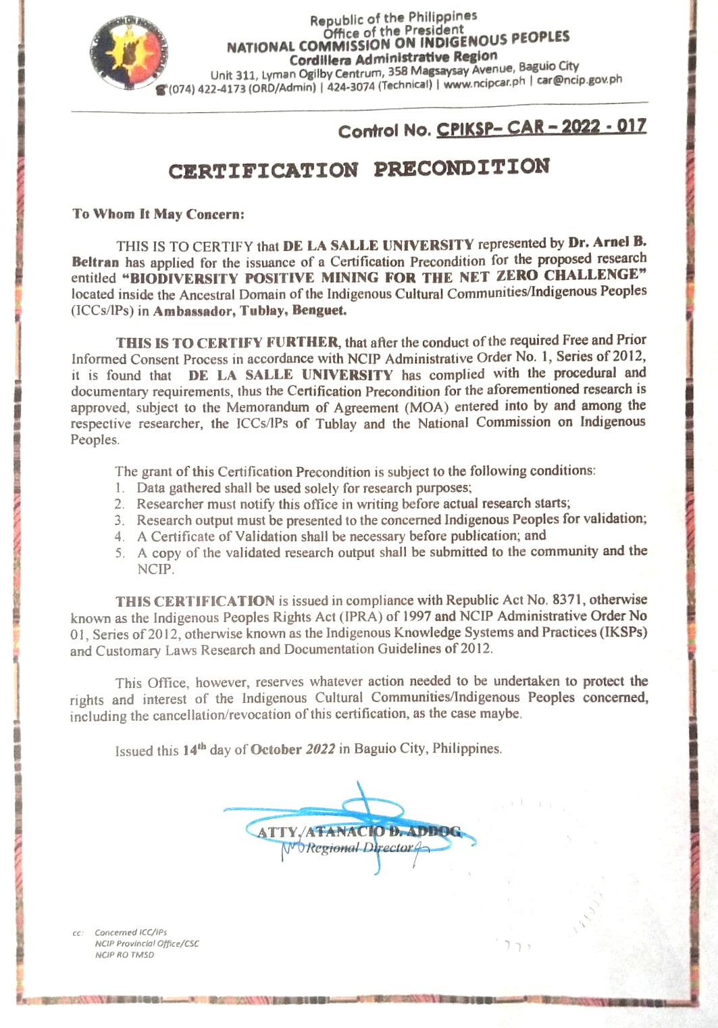
Figure S1. Certificate of Precondition issued by the National Commission on Indigenous People (NCIP), Cordillera Administrative Region.

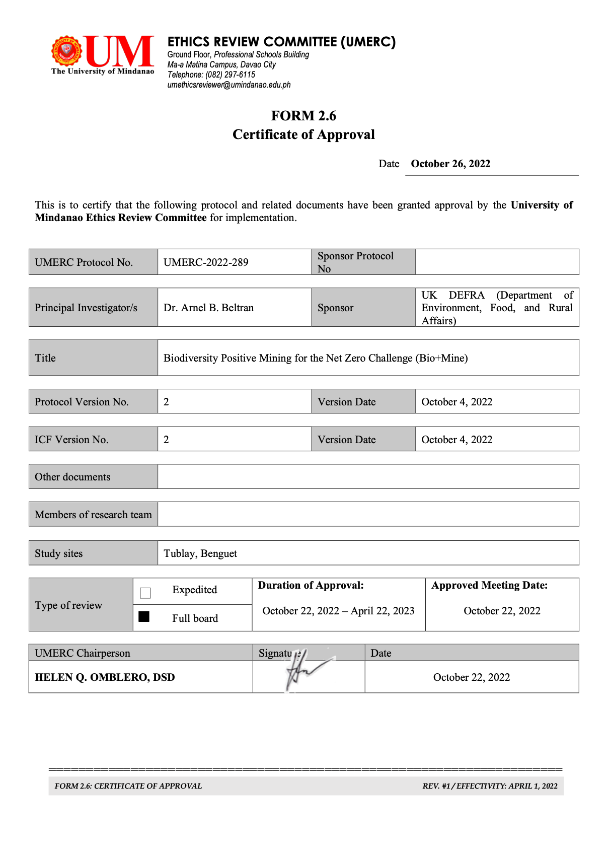
Figure S2. Ethics approval granted by the University of Mindanao Ethics Review Committee, Davao City.

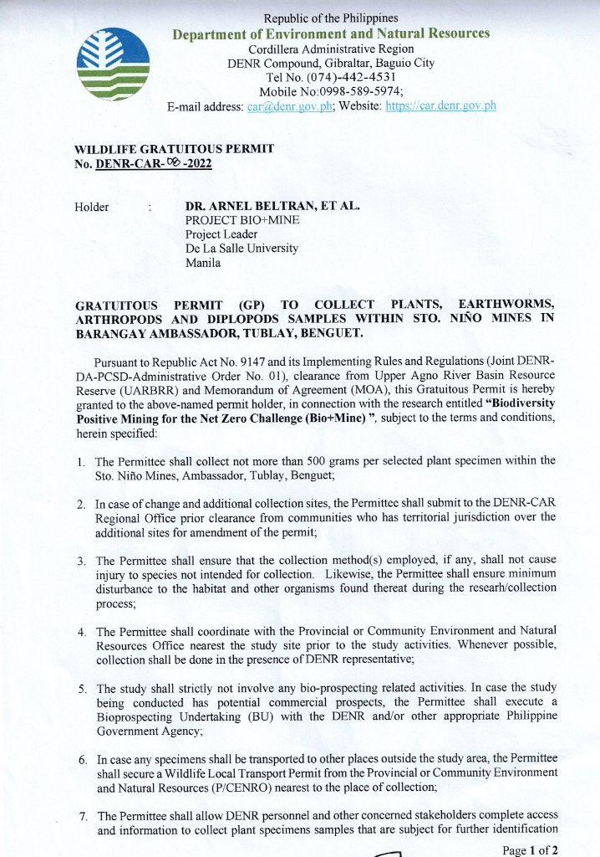
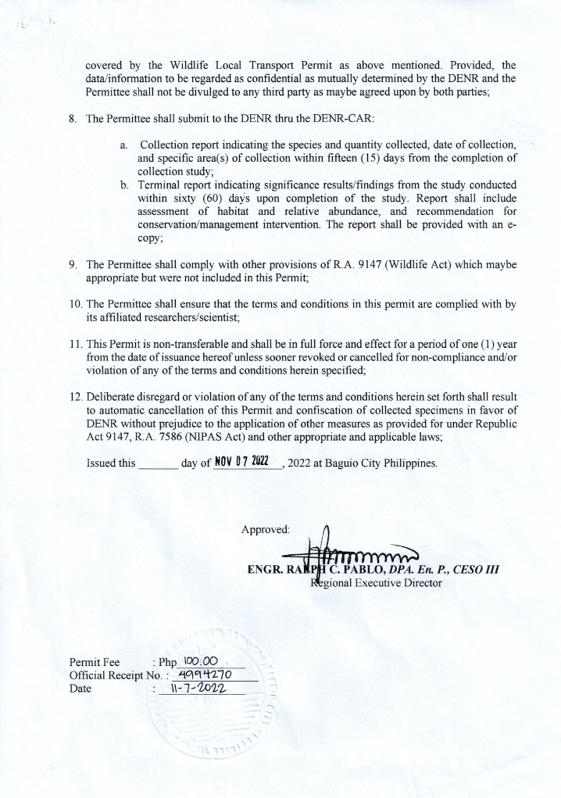
Figure S3. Wildlife Gratuitous Permit issued by the Department of Environment and Natural Resources, Cordillera Administrative Region.
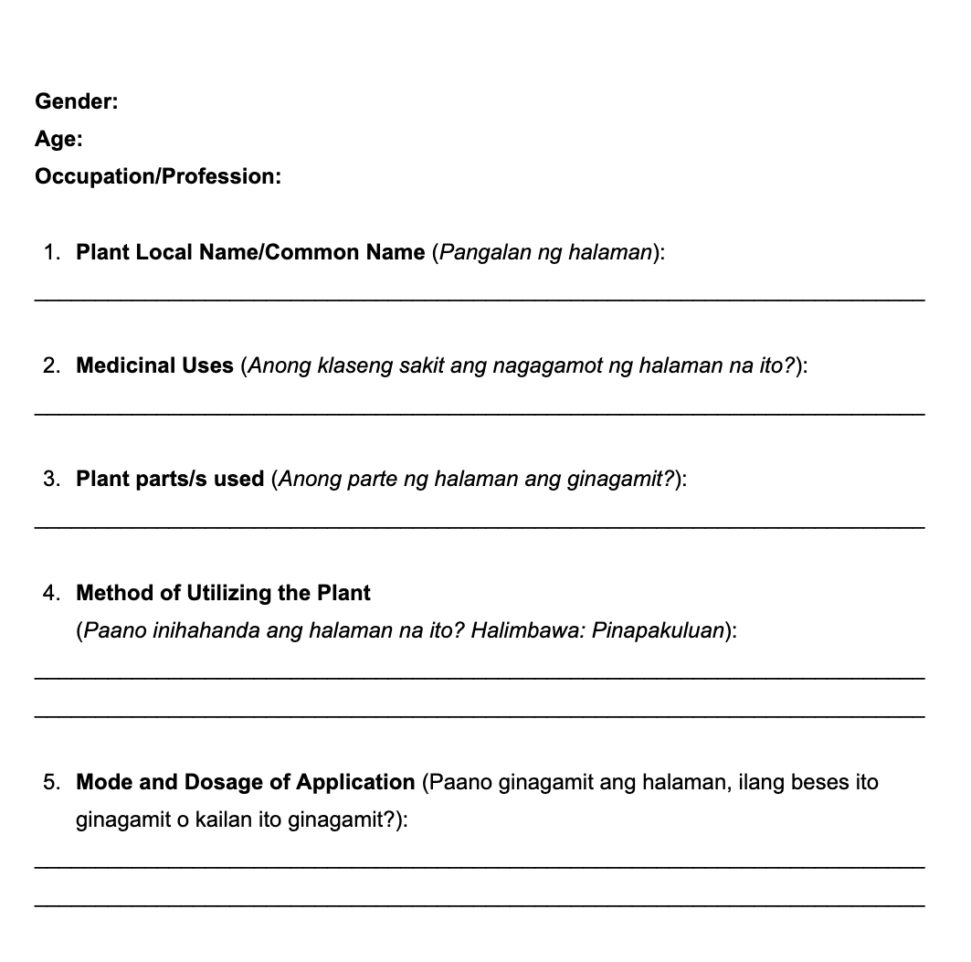
Figure S4. Ethnobotanical survey questionnaire used during the collection of data.

