Support Information

Development of An Arduino-based Automatic Hybrid Camera Track Mounting for Hybrid Learning Classroom

Eko Risdianto ^{1,a*)}; Rahdi Rahdi ^{2,b)}; Danny Rizki Nugraha ^{3,c)}; Mageswaran Sanmugam ^{4,d) )}; Deshinta Arrova Dewi ^{5,e)}; Hera Anis Kartika ^{2,f)}; Jeni Fitria ^{2,g)}; Agus Sumantri ^{6,h) )}; Andi Kristanto ^{7,i)}
¹Doctoral Program in Education, University of Bengkulu, Kota Bengkulu-38122 (Indonesia)
²Department of Physics Education, University of Bengkulu, Kota Bengkulu-38122 (Indonesia)
³Department of Mechanical Engineering, University of Bengkulu, Kota Bengkulu-38122 (Indonesia)
⁴Centre for Instructional Technology and Multimedia, University of Science Malaysia, Pulau Pinang-11800 (Malaysia)
⁵Center for Data Science and Sustainable Technologies, INTI International University, Nilai-71800. (Malaysia)
⁶ Belmawa, Direktorat Jenderal Pendidikan Tinggi, Jakarta Pusat-10270, (Indonesia)
⁷Educational Technology Study Program, Universitas Negeri Surabaya, Surabaya-60213 (Indonesia)
^{a)}Correspondence: eko_risdianto@unib.ac.id
^{b)} rahdi71@guru.sma.belajar.id
^{c)} danyrizky269@gmail.com
^{d)} mageswaran@usm.my
^{e)} deshinta.ad@newinti.edu.my
^{f)}heraaniskartika@gmail.com
^{g)}jefitria@gmail.com
^{h)}sumantri@kemdiktisaintek.go.id
^{i)}andikristanto@unesa.ac.id

ORCIDs:
First AUTHOR : https://orcid.org/0000-0002-5950-2238
Second AUTHOR : https://orcid.org/0009-0002-7092-0745
Third AUTHOR : https://orcid.org/0009-0000-1065-7290
Fourth AUTHOR : https://orcid.org/0000-0003-3313-4462
Fifth AUTHOR : https://orcid.org/0000-0003-1488-7696
Sixth AUTHOR : https://orcid.org/0009-0009-0404-3159
Seventh AUTHOR : https://orcid.org/0009-0006-7135-0683
Eighth AUTHOR : https://orcid.org/0009-0008-6536-4688
Nine AUTHOR : https://orcid.org/0000-0002-8127-2707

ACKNOWLEDGEMENT

The authors would like to express their deepest gratitude to the Institute for Research and Community Service (LPPM) of the University of Bengkulu for the support and facilities provided during the research process. Special thanks are also extended to the Faculty of Teacher Training and Education, University of Bengkulu for their invaluable guidance and motivation. The author would also like to thank Universiti Sains Malaysia (USM) for their significant contribution to the development of this research, both in the form of ideas, data, and constructive suggestions. Thanks are also due to the Directorate of Learning and Student Affairs (BELMAWA), Ministry of Higher Education, Science, and Technology of the Republic of Indonesia. We also extend our gratitude to the Indonesian Association of Educational Technology Study Programs (APS-TPI) for providing supervision for this research.

AUTHOR CONTRIBUTIONS

The conceptualization and design of the learning technology were carried out by E. R., D. A. D., and R. R.. The methodology was developed by E. R.. Software development was handled by R. R.. The validation process was conducted by E. R., A. S., R. R., D. A. D., and D. R. N.. Formal analysis and investigation were performed by E. R., who also contributed to resource provision and data curation. The original draft was prepared by E. R., with writing, review, and editing carried out by M. S.and H. A. K.. The 2D and 3D visualizations were managed by D. R. N.. Project supervision was provided by R. R., J. F., A. K.and D. A. D.. This study is the outcome of an interdisciplinary collaboration, integrating expertise from Educational Technology, Physics, Online Learning, Artificial Intelligence, Mechanical Engineering, Learning Models, and Instrumentation.

CONFLICT OF INTEREST

We declare no personal circumstances or interests that may be perceived as influencing the representation or interpretation of the research results reported in this article. Furthermore, there was no involvement of the funding sponsors in the selection of the research project, the design of the study, the collection, analysis, or interpretation of data, the writing of the manuscript, or the decision to publish the results. The authors declare that they have no conflict of interest.
DECLARATION OF GENERATIVE AI AND AI-ASSISTED TECHNOLOGIES IN THE MANUSCRIPT PREPARATION

During the preparation of this work, the authors utilized several AI tools to assist with manuscript development. Grammarly was used to help adjust and improve the English language and grammar. Research Rabbit AI was used to search for relevant references and research studies. After using these tools, the authors thoroughly reviewed and edited the content as needed, taking full responsibility for the content of the publication.

Table S1. Results of lecturer questionnaire analysis.
No | College Name | Number of respondents | Number of Scores Obtained | Total Score | Percentage | Group
1 | University of Bengkulu | 18 | 1085 | 1152 | 94.18% | Strongly agree
2 | University of Muhammadiyah Bengkulu | 4 | 232 | 256 | 90.63% | Strongly agree
3 | Polytechnic of the Ministry of Health Bengkulu | 5 | 298 | 320 | 93.13% | Strongly agree
4 | Raja Ali Haji Maritime University | 1 | 55 | 64 | 85.94% | Strongly agree
5 | Marine University | 1 | 63 | 64 | 98.44% | Strongly agree
6 | University of Muhammadiyah Metro | 1 | 63 | 64 | 98.44% | Strongly agree
7 | INSTIPER Yogyakarta | 2 | 120 | 128 | 93.75% | Strongly agree
8 | UNIPA Manokwari | 1 | 63 | 64 | 98.44% | Strongly agree
9 | PGRI University Palembang | 2 | 127 | 128 | 99.22% | Strongly agree
10 | Khairun University | 2 | 116 | 128 | 90.63% | Strongly agree
11 | University of Muhammadiyah Palembang | 1 | 63 | 64 | 98.44% | Strongly agree
12 | Medan Aviation Polytechnic | 1 | 64 | 64 | 100% | Strongly agree
13 | STIKES Baiturrahim Jambi | 1 | 63 | 64 | 98.44% | Strongly agree

Table S2. Validation results of each indicator.
Indicators | Average Validation Results | Group
Tool efficiency | 97% | Highly worthy
Tool durability | 96% | Highly worthy
Aesthetic | 92% | Highly worthy
Precision values | 97% | Highly worthy
Salvation | 92% | Highly worthy

Table S3. Respect the safety factor.
Equipment | Safety Factor (FOS)
Aircraft components | 1.5–2.5
Boiler | 3.5–6.0
Bolt | 8.5
Cast iron wheels | 20
Machine components | 6–8
Heavy-duty shaft | 10–12
Lifting equipment - hooks | 8–9
Pressure vessel | 3.5–6.0
Turbine components - static | 6–8
Turbine components - rotating | 2–3
Springs, large, heavy-duty | 4.5
Structural steel work in buildings | 4–6
Structural steel work on bridges | 5–7
Wire rope | 8–9

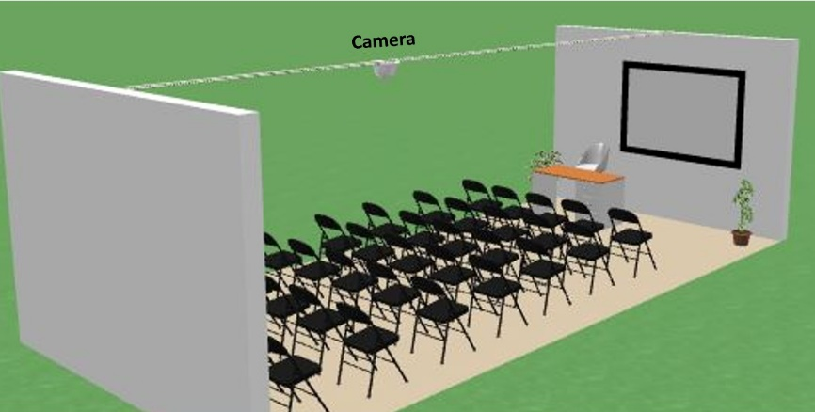
Figure S1. Arduino-based automatic hybrid camera track mounting tool installed in room

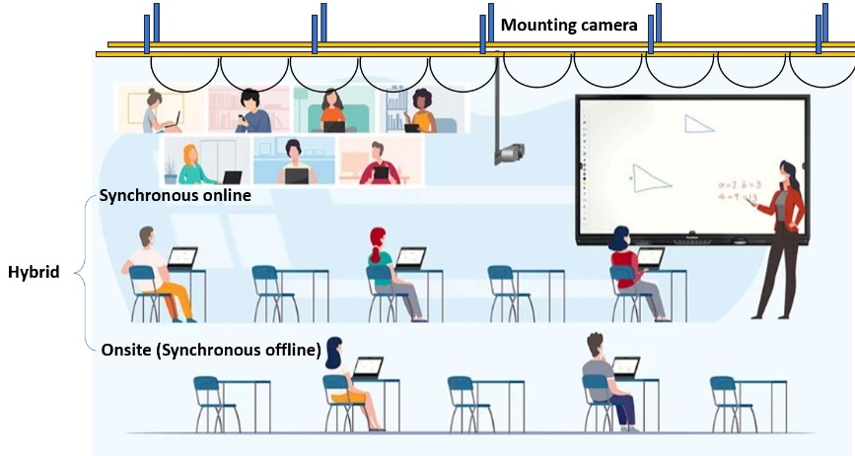
Figure S2. User simulation in this work

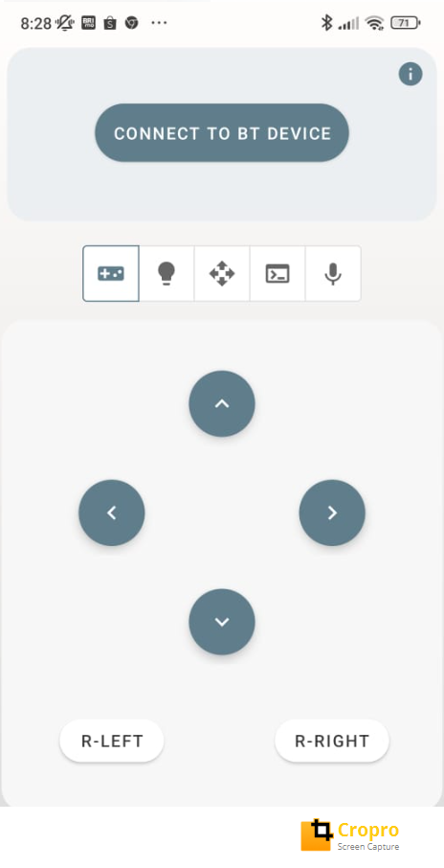
Figure S3. Remote control design for the controller

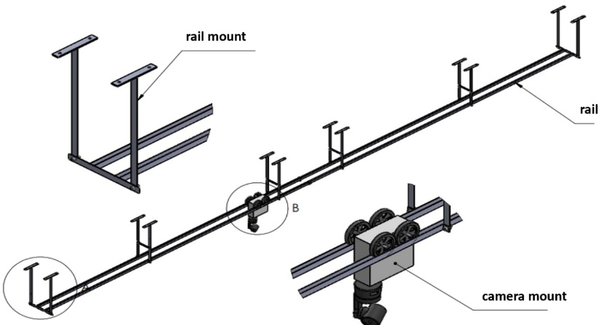
Figure S4. 3D smart mounting camera
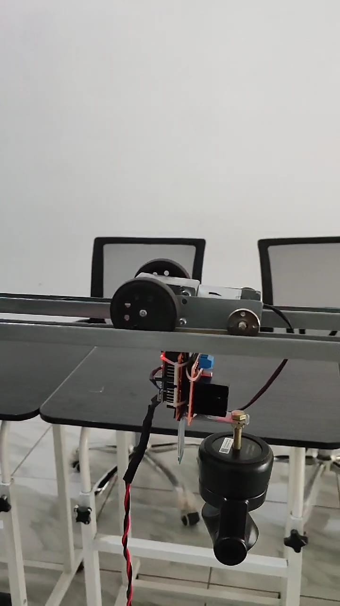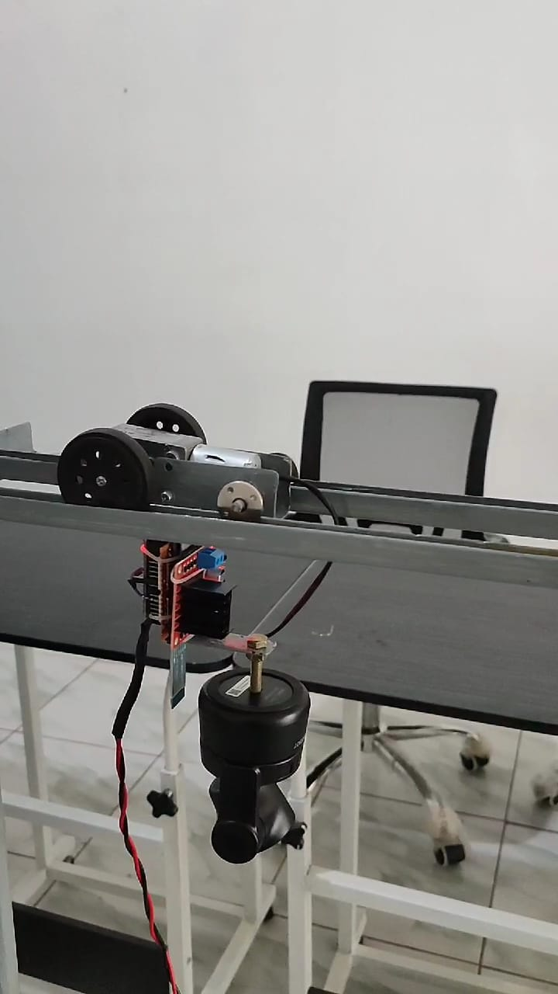
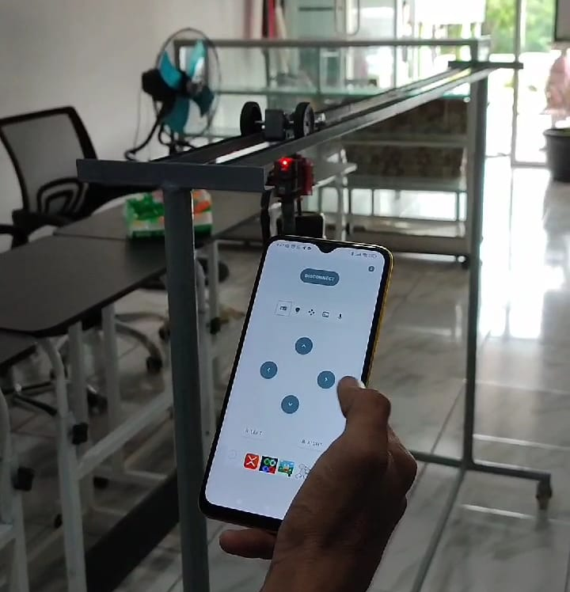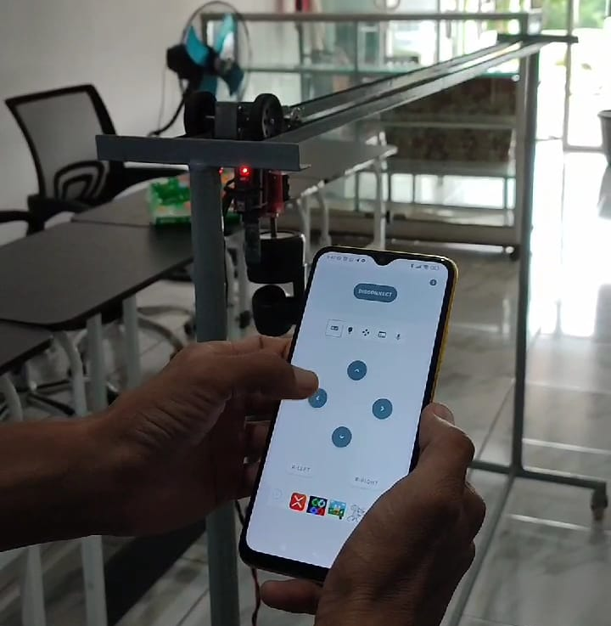
Figure S5. Results of the development of an Arduino-based automatic hybrid camera track mounting tool

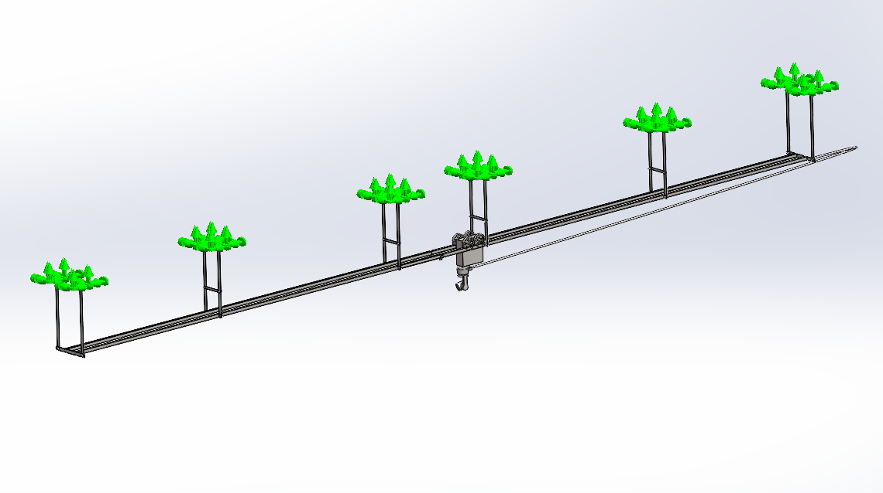
Figure S6. Focusing on rail mounts
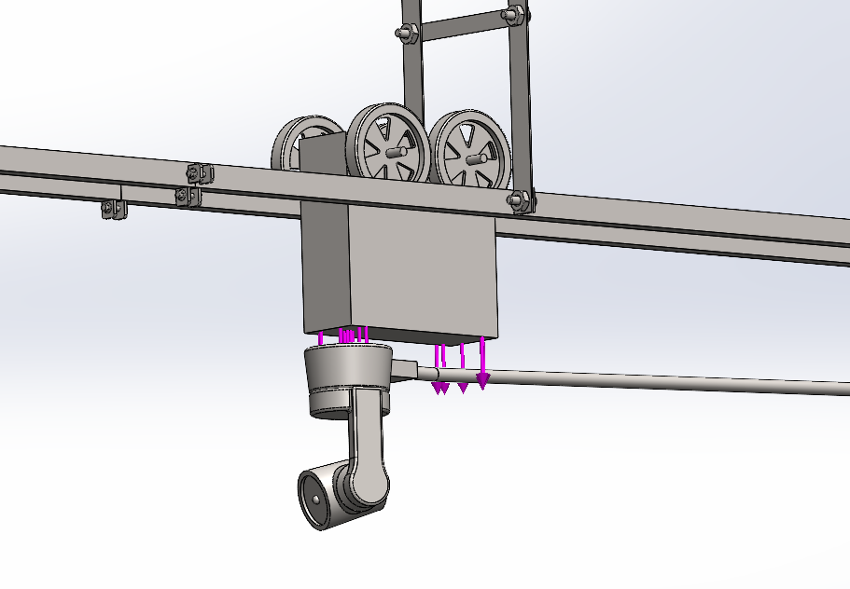
Figure S7. Sliding Carriage for hanging and moving the AI camera.
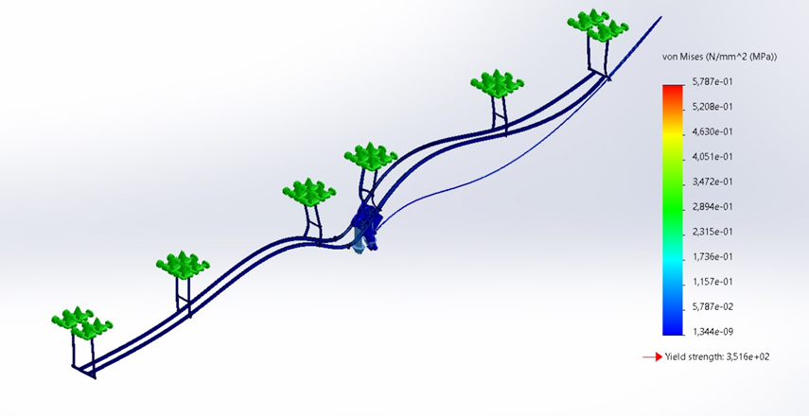
Figure S8. Simulation results in the form of voltage values

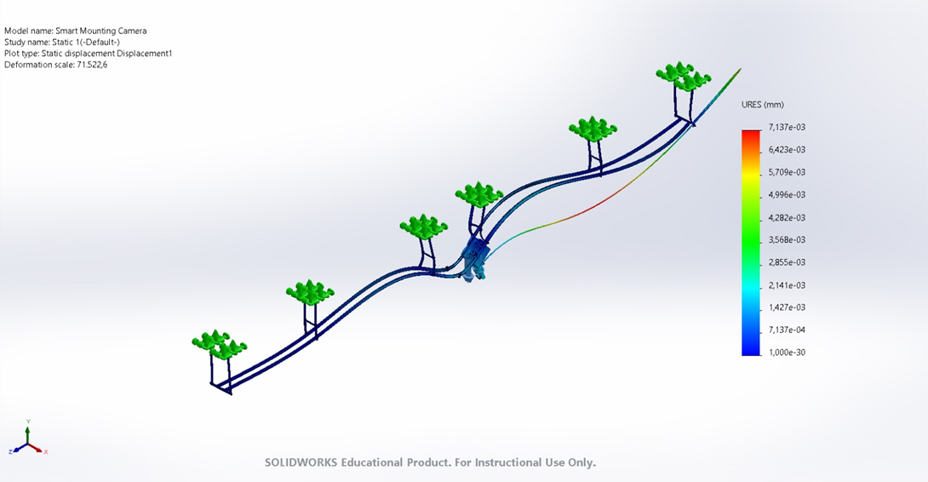
Figure S9. Simulation results in the form of displacement values

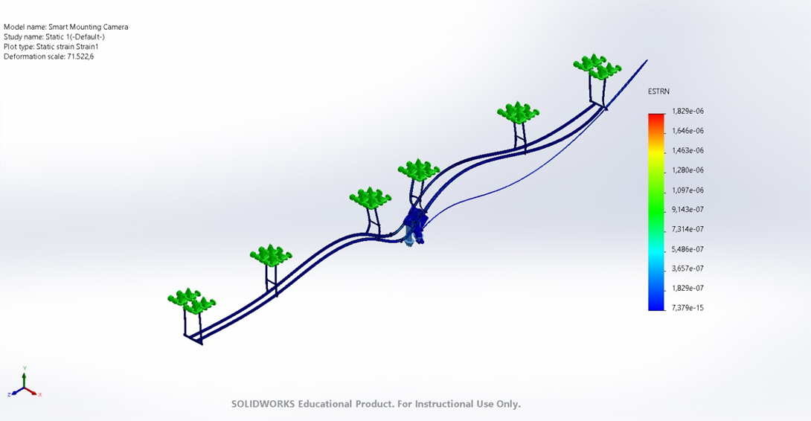
Figure S10. Simulation results in the form of strain values

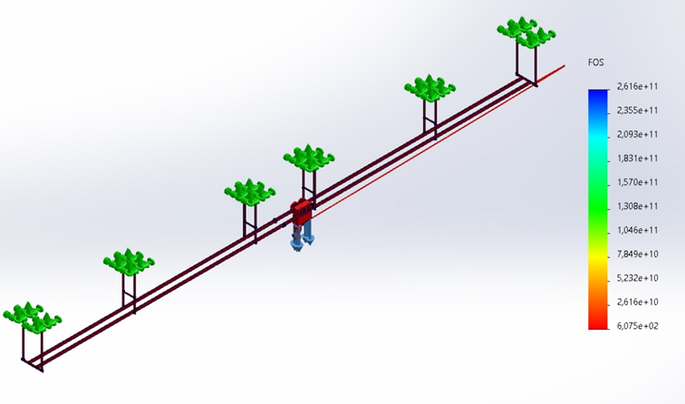
Figure S11. Simulation results in the form of safety factor values

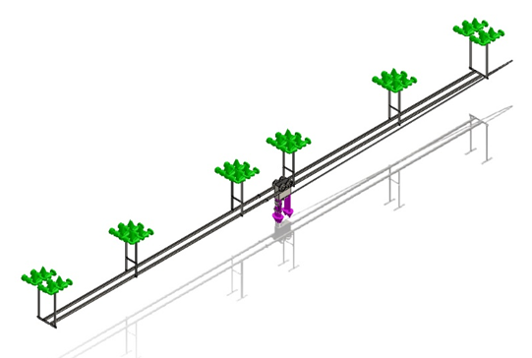
Figure S12. Intelligent installation camera loading simulation
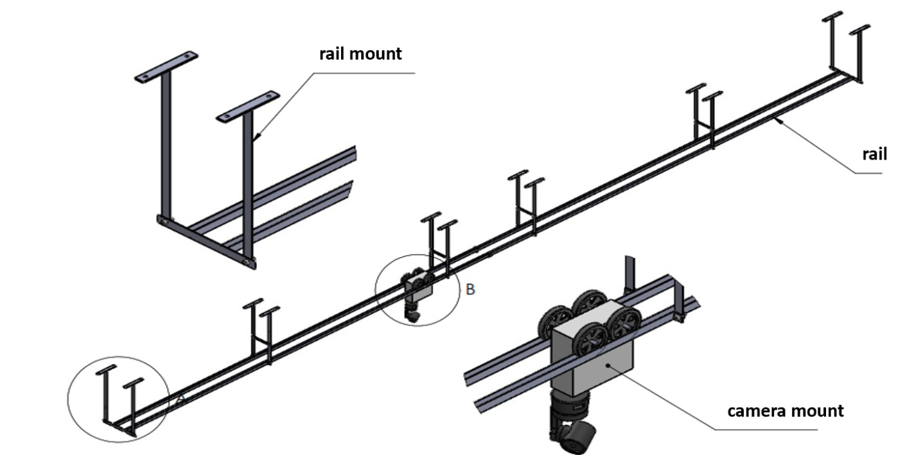
Figure S13. 3D Smart Mounting Camera.
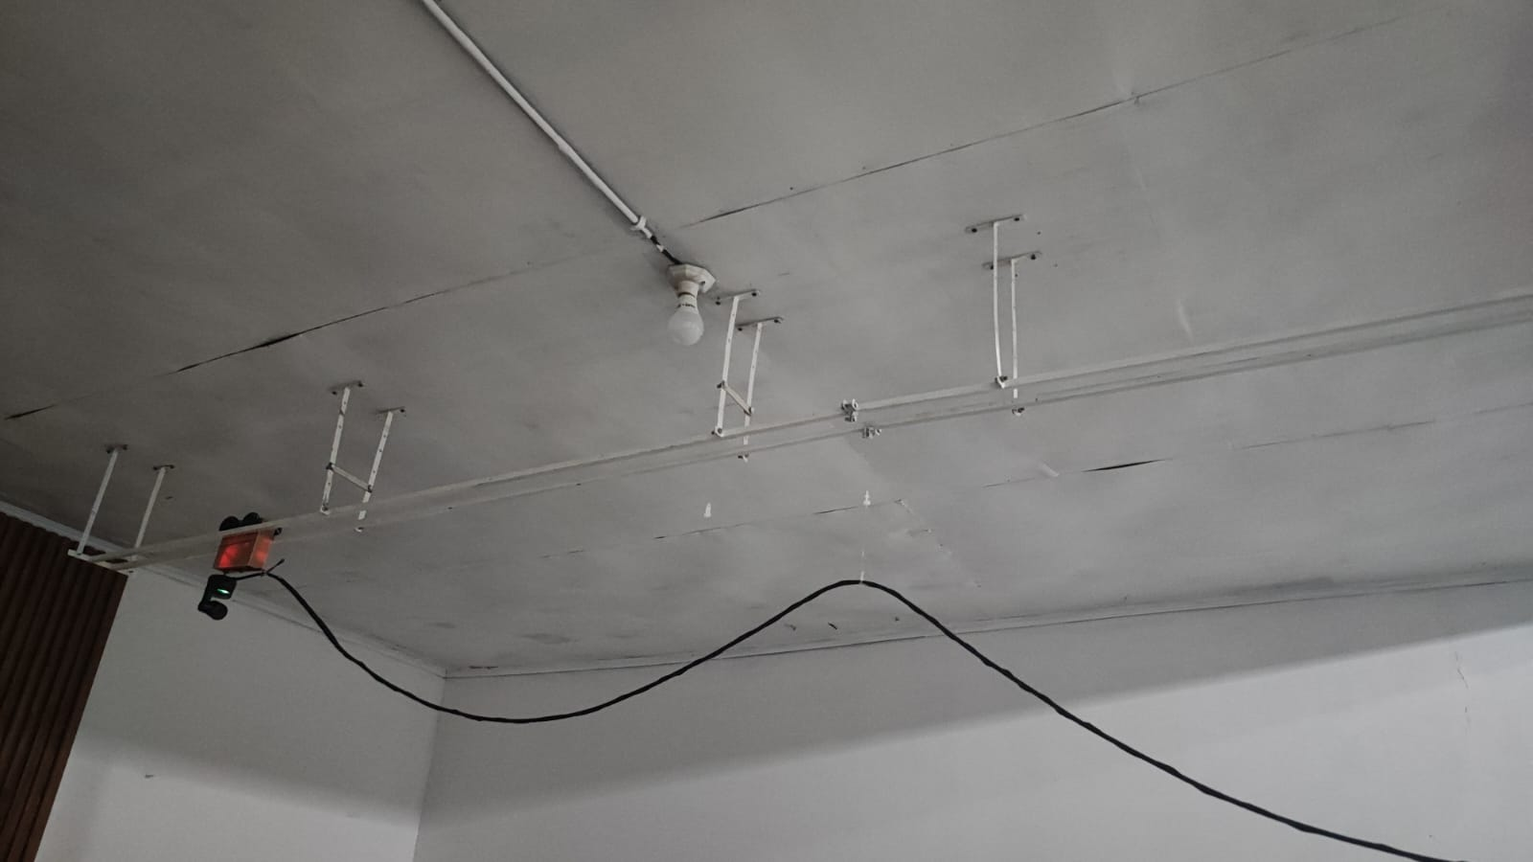
Figure S14. Final prototype of the Arduino-based automatic hybrid camera track system installed in a smart hybrid learning classroom

