Support Information

Application of QUAL2K for Water Quality Impact Assessment of Mining-Impacted River: A Case Study of Sungai Rui, Perak

Fasihah Mohd Yusof ^{1,a)}, Nor Rohaizah Jamil ^{1,b,*)}
¹ Faculty of Forestry and Environment, Universiti Putra Malaysia, Selangor-43400 (Malaysia)
^{a)}fasihah.mohd.yusof@gmail.com
^{b)}Correspondence: norohaizah@upm.edu.my

ORCIDs
First AUTHOR : https://orcid.org/0009-0005-2300-1991
Second AUTHOR : https://orcid.org/0000-0001-5004-3891

ACKNOWLEDGEMENT

We would like to express our sincere gratitude to Assoc. Prof. Dr. Rohaizah Jamil from Universiti Putra Malaysia (UPM) for her invaluable supervision, guidance, and support throughout this research. This research was supported Ambiance Solution Services, Malaysia.

AUTHOR CONTRIBUTIONS

Conceptualization, methodology, writing—review and editing, F. M. Y., and N. R. J.; writing—original draft preparation, and funding acquisition, F. M. Y. All authors have read and agreed to the published version of the manuscript.

CONFLICT OF INTEREST

The authors declare no conflict of interest.

DECLARATION OF GENERATIVE AI AND AI-ASSISTED TECHNOLOGIES IN THE MANUSCRIPT PREPARATION

Not applicable.
Table S1. Parameters calibration for the model.
- Sg Duri Model Calibration
- Discharge  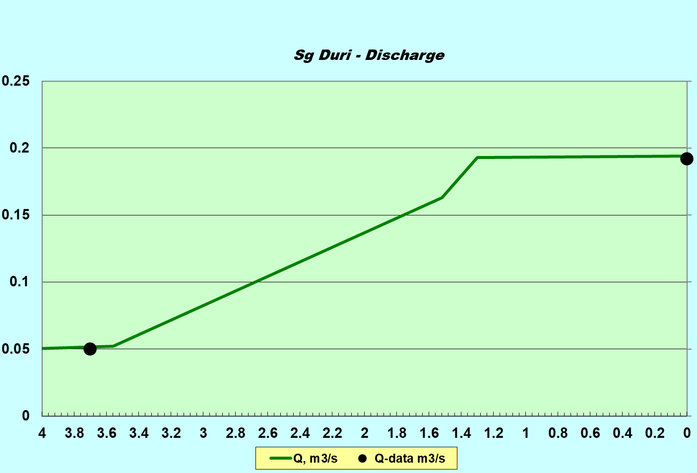  Simulated TSS  Observed TSS | - pH  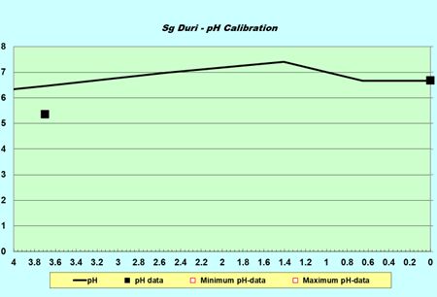  Simulated TSS  Observed TSS
- BOD₅  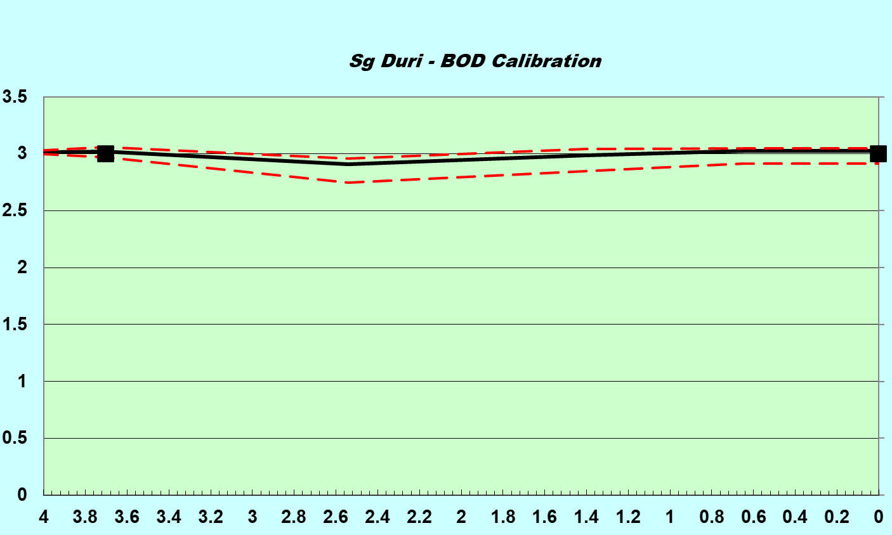  Simulated TSS  Observed TSS | - TSS  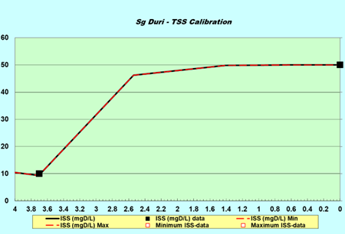  Simulated TSS  Observed TSS
- NH₃N
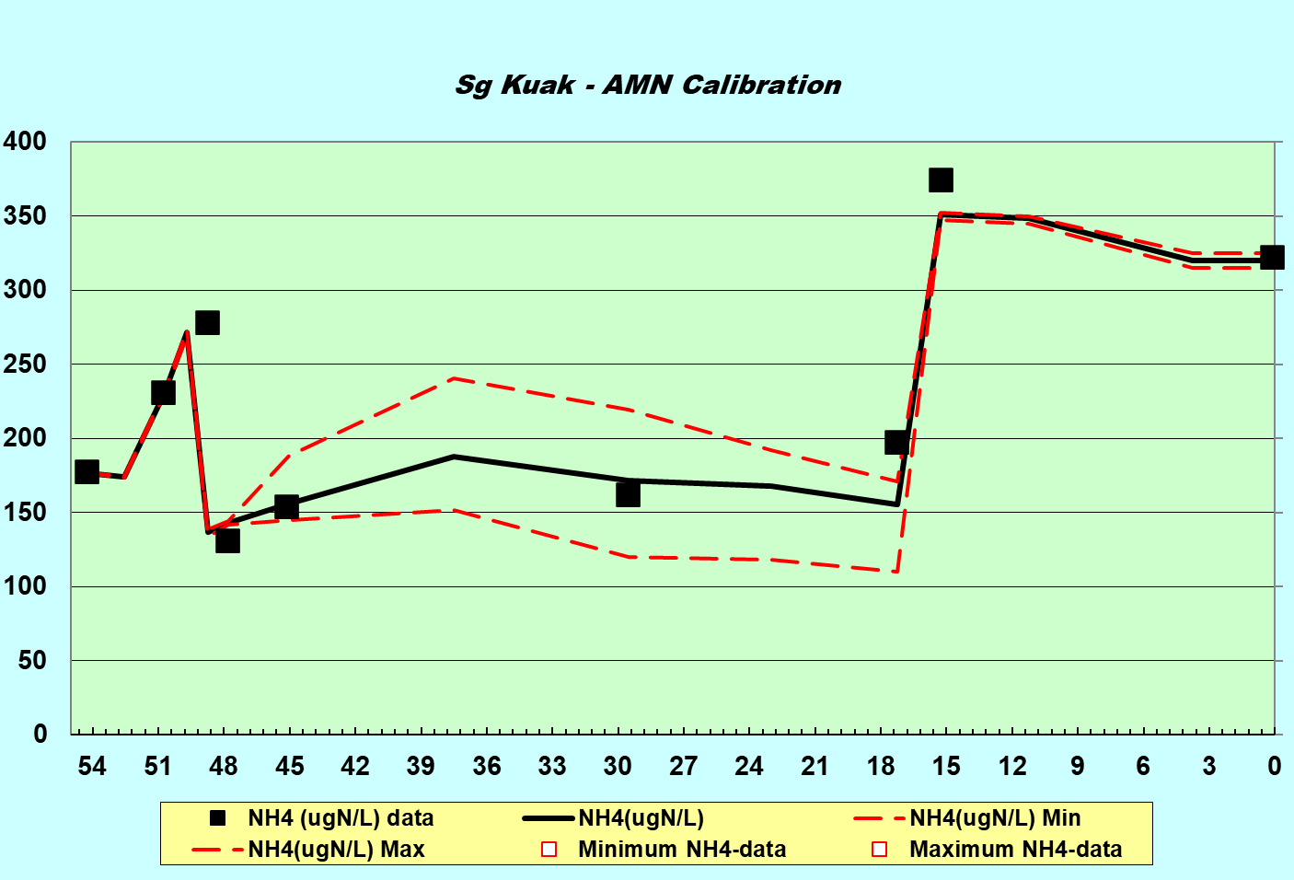
Simulated TSS
Observed TSS
- Sg Kuak-Perak Model Calibration
- Discharge  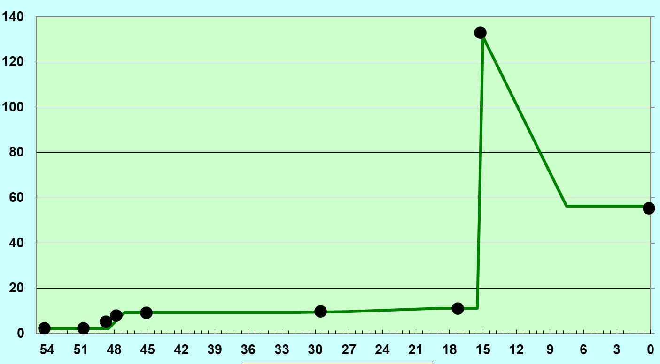  Observed Q  Simulated Q |  | - pH  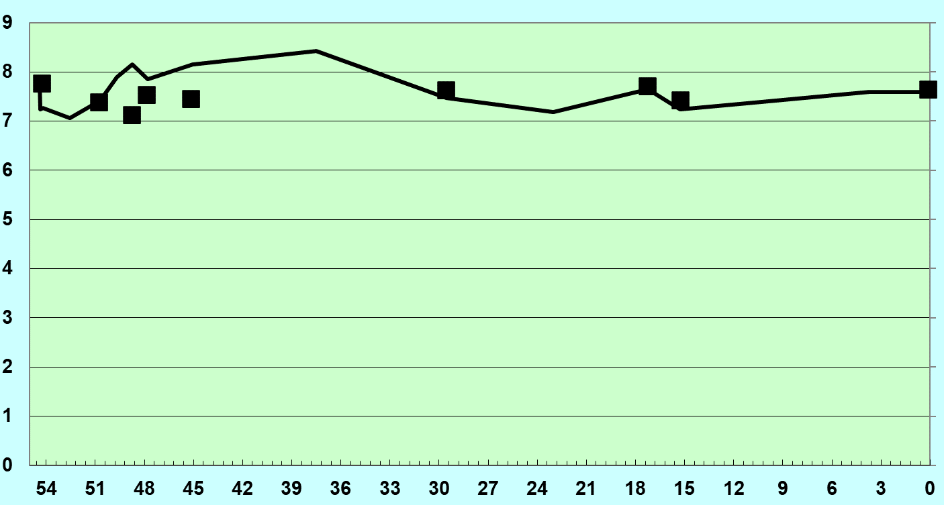  Observed pH  Simulated pH
- BOD₅  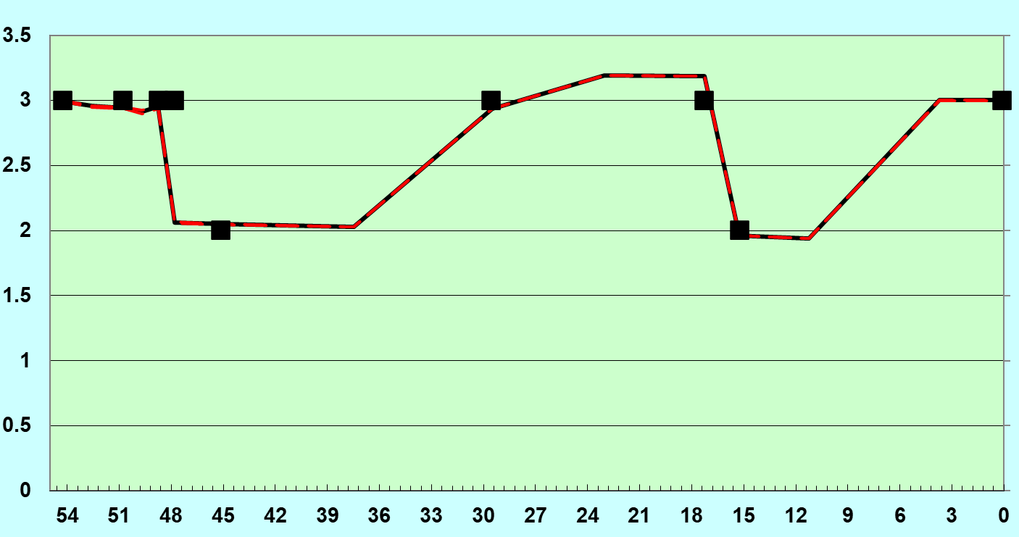  Observed BOD₅  Simulated BOD₅ |  | - TSS  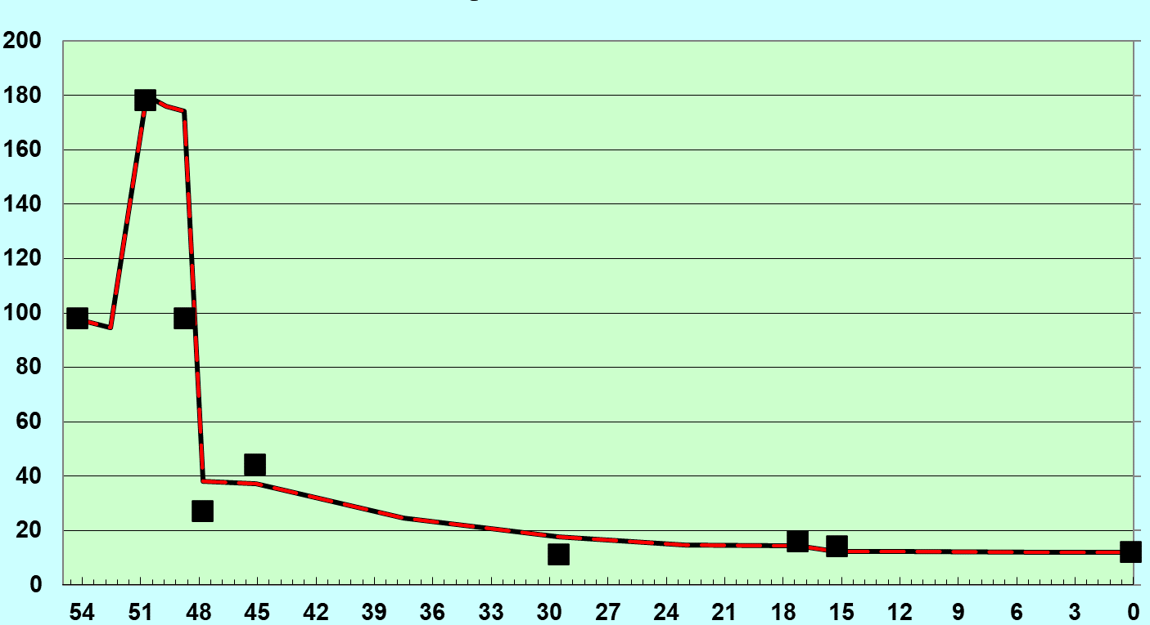  Observed TSS  Simulated TSS
- NH₃N
Simulated TSS
Observed TSS

Table S2. Simulated TSS concentration at selected points.
Scenario | Existing condition | Development Phase with BMPs Failure | Development Phase with BMPs | Operation phase with Tailing Pond Outburst | Operation phase with Tailing Pond Overflow
WQ9: Project Site (KM1.41 – Sg Duri) | 49.84  Class II | 3979.86  Class V | 47.99  Class II | 60.46  Class III | 60.92  Class III
PS1: Sg Duri-Kuak Confluent  (KM0.00 – Sg Duri) | 50.02  Class III | 3976.22  Class V | 48.04  Class II | 60.45  Class III | 60.92  Class III
WQ3: Sg Rui-Perak Confluent  (KM17.25 – Sg Kuak) | 13.97  Class I | 3143.75  Class V | 27.56  Class II | 59.37  Class III | 50.80  Class III
WQ1: Before Gandah Water Intake  (KM0.00 – Sg Perak) | 12.04  Class I | 985.90  Class V | 13.99  Class I | 47.57  Class II | 23.89  Class I

Table S3. Simulated pollutant concentration at KM1.41 and KM0.00
 | WQ9: Project Site (KM1.41 – Sg Duri) |  |  | PS1: Sg Duri-Kuak Confluent  (KM0.00 – Sg Duri)
Scenario | Existing condition | Operation phase with Tailing Pond Outburst | Operation phase with Tailing Pond Overflow | Existing condition | Operation phase with Tailing Pond Outburst | Operation phase with Tailing Pond Overflow
pH | 7.41 | 5.90 | 5.34 | 6.66 | 5.95 | 5.43
BOD | 2.99 | 24.79 | 24.40 | 3.02 | 24.69 | 24.08
NH₃N | 0.24 | 11.92 | 11.78 | 0.21 | 11.88 | 11.70

Table S4. Simulated pollutant concentration at KM17.25 and WQ1
 | WQ3: Sg Rui-Perak Confluent  (KM17.25 – Sg Kuak) |  |  | WQ1: Before Gandah Water Intake
Scenario | Existing condition | Operation phase with Tailing Pond Outburst | Operation phase with Tailing Pond Overflow | Existing condition | Operation phase with Tailing Pond Outburst | Operation phase with Tailing Pond Overflow
pH | 7.65 | 6.08 | 6.69 | 7.60 | 6.26 | 7.17
BOD | 0.08 | 23.29 | 19.09 | 3.00 | 18.27 | 6.93
NH₃N | 0.155 | 11.387 | 8.975 | 0.320 | 8.571 | 2.946

