Support Information
Enhancing Supercapacitor Cell Capacitance through Liquid-Phase Exfoliation Synthesis of Graphene

Buky Wahyu Pratama ^{1,a)}; Haris Suhendar ^{2,b)};
Wipsar Sunu Brams Dwandaru ^{3,c)}; Iman Santoso ^{1,d*)}

¹Department of Physics, Universitas Gadjah Mada, Yogyakarta-55281 (Indonesia)
²Department of Physics, Universitas Negeri Jakarta, Jakarta-13220 (Indonesia)
³Department of Physics, Universitas Negeri Yogyakarta, Yogyakarta-55281 (Indonesia)

^{a)} buky.wahyupratama@gmail.com
^{b)} haris.suhendar@mail.ugm.ac.id
^{c)} wipsarian@uny.ac.id
^{d*)} Correspondence: iman.santoso@ugm.ac.id

ORCIDs:
First AUTHOR : https://orcid.org/0000-0002-4962-5226
Second AUTHOR : https://orcid.org/0000-0001-6385-6090
Third AUTHOR : https://orcid.org/0000-0002-9692-4640
Fourth AUTHOR : https://orcid.org/0000-0003-2695-8965

ACKNOWLEDGEMENT

This research was supported by Indonesian Endowment Fund for Education (Lembaga Pengelola Dana Pendidikan (LPDP)) for providing scholarship and financial support [LOG-8575/LPDP.3/2024].

AUTHOR CONTRIBUTIONS

Conceptualization, B. W. P.; Methodology, B. W. P.; Software, H. S.; Validation, B. W. P. and I. S.; Formal Analysis, B. W. P.; Investigation, I. S. and W. S. B.; Resources, B. W. P.; Data Curation, B. W. P., H. S., and I. S.; Writing – Original Draft Preparation, B. W. P.; Writing – Review & Editing, I. S. and W. S. B.; Visualization, B. W. P.; Supervision, I. S. and W. S. B.; Funding Acquisition, B. W. P.

CONFLICT OF INTEREST

The authors declare no conflict of interest.

DECLARATION OF GENERATIVE AI AND AI-ASSISTED TECHNOLOGIES IN THE MANUSCRIPT PREPARATION

“Not applicable”.

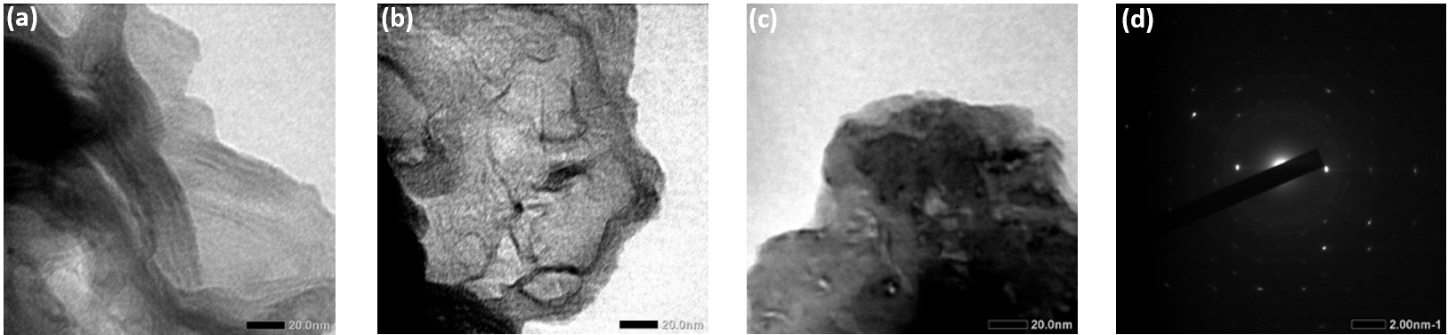
Fig. S1. Transmission electron microscope (TEM) image of graphene (a) C15, (b) C30, (c) C90, and (d) diffraction from C90.

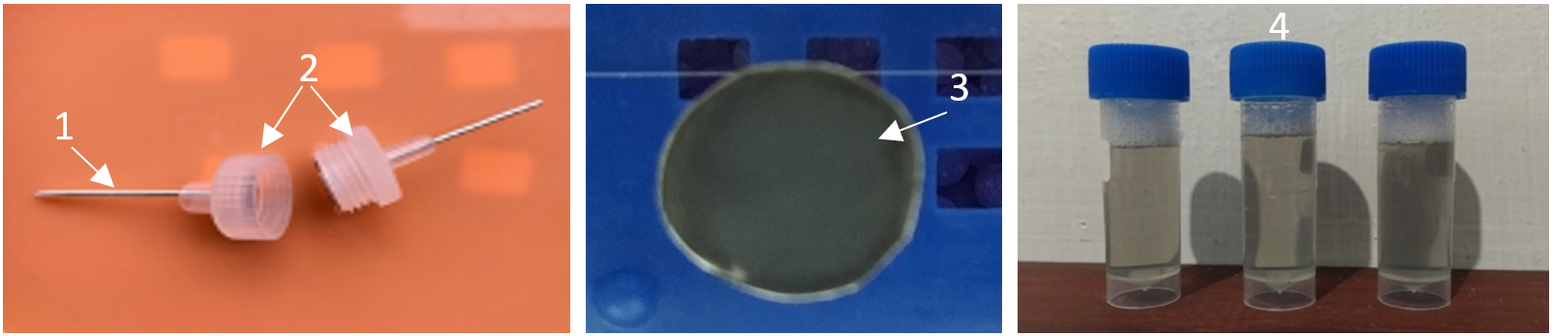
Fig. S2. Materials and Supercapacitor design; (1) Silver plate (Collector); (2) Costume case capacitor; (3) Synthesized graphene on silver plate; (4) Graphene in LAS solution.

Tabel S1. C15 electrode fitting parameter.
C15 |  | C | ESR | Rlk
47 mA | Charging | 16.41 | 23.87 | 2520.42
47 mA | Discharging | 10.74 | 1108.25 | 4557.87
59 mA | Charging | 12.28 | 5.54 | 1708.74
59 mA | Discharging | 8.95 | 877.92 | 3525.31
71 mA | Charging | 9.71 | 52.18 | 1256.53
71 mA | Discharging | 7.75 | 716.21 | 2844.36

Tabel S2. C30 electrode fitting parameter.
C30 |  | C | ESR | Rlk
48 mA | Charging | 19.12 | 3.93 | 2016.86
48 mA | Discharging | 15.52 | 1157.96 | 4261.66
60 mA | Charging | 19.21 | 3.14 | 1613.50
60 mA | Discharging | 12.29 | 925.92 | 3408.88
72 mA | Charging | 15.19 | 2.62 | 1344.58
72 mA | Discharging | 10.98 | 759.99 | 2829.13

Tabel S3. C90 fitting parameter.
C90 |  | C | ESR | Rlk
51 mA | Charging | 22.31 | 3.93 | 1966.87
51 mA | Discharging | 16.29 | 1097.28 | 4150.98
63 mA | Charging | 20.33 | 3.14 | 1573.50
63 mA | Discharging | 13.59 | 888.75 | 3331.71
76 mA | Charging | 17.25 | 2.62 | 1311.25
76 mA | Discharging | 12.90 | 745.96 | 2781.76

