Support Information

Antiplasmodial and Metabolite Profiling of Hyrtios sp. Sponge Extract from Southeast Sulawesi Marine Using LC-HRMS, Molecular Docking, Pharmacokinetic, Drug-likeness, Toxicity, and Molecular Dynamics Simulation

Maria Ludya Pulung^{1,3, a)}; Respati Tri Swasono^{1, b)}; Eti Nurwening Sholikhah^{2, c)}; Radite Yogaswara^{1,4, d)}; Gian Primahana^{5, e)}; Tri Joko Raharjo^{1, f, *)}

¹ Department of Chemistry, Universitas Gadjah Mada, Yogyakarta-55281 (Indonesia)
² Department of Pharmacology and Therapy, Universitas Gadjah Mada, Yogyakarta-55281 (Indonesia)
³ Department of Chemistry, Universitas Papua, Manokwari-98312 (Indonesia)
⁴ Department of Chemistry, Universitas Papua, Manokwari-98312 (Indonesia)
⁵ Research Centre for Pharmaceutical Ingredients and Traditional Medicine, National Research and Innovation Agency (BRIN), Banten-15314 (Indonesia)
^{a)}l.pulung@unipa.ac.id
^{b)}respati@ugm.ac.id
^{c)} etinurweningsholikhah@ugm.ac.id
^{d)}r.yogaswara@unipa.ac.id
^{e)}gian.primahana@brin.go.id
^{f)}Correspondence: trijr_mipa@ugm.ac.id

ORCIDs:
First AUTHOR : https://orcid.org/0000-0002-2458-7198
Second AUTHOR : https://orcid.org/0000-0003-0762-6930
Third AUTHOR : https://orcid.org/0000-0002-6545-8691
Fourth AUTHOR : https://orcid.org/0000-0002-5937-6200
Fifth AUTHOR : https://orcid.org/0000-0001-8176-3859
Sixth AUTHOR : https://orcid.org/0000-0003-0615-5241

ACKNOWLEDGEMENT

The authors express gratitude for the support of the Rekognisi Tugas Akhir (RTA) program at Gadjah Mada University with a reference number 5286/UN1.P1/PT.01.03/2024, and the first author would like to thank Indonesia Endowment Fund for Education Agency (LPDP), Ministry of Finance, and Republic of Indonesia for the support of the doctoral program scholarship at Gadjah Mada University (2022‒2026).

AUTHOR CONTRIBUTIONS

The authors have made significant contributions to their respective fields including Conceptualization, M. L. P. and T. J. R.; Methodology, M. L. P. and R. T. S.; Software, R. Y.; Validation, T. J. R., R. T. S. and E. N. S.; Formal Analysis and Data Curation, M. L. P. and G. P.; Investigation, M. L. P. and E. N. S.; Resources, Draft Preparation, Writing – Original and Writing – Review & Editing, M. L. P.; Visualization, R. Y. and G. P.; Supervision, T. J. R., R. T. S. and E. N. S.

CONFLICT OF INTEREST

The authors declare that they have no competing interests.

DECLARATION OF GENERATIVE AI AND AI-ASSISTED TECHNOLOGIES IN THE MANUSCRIPT PREPARATION

Not applicable.

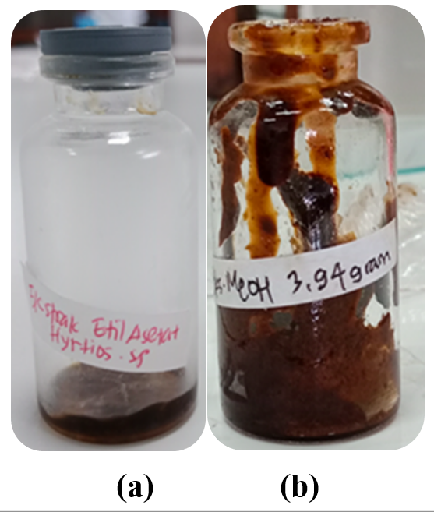
Figure S1. Concentrated (a) EtOAc and (b) MeOH extracts.

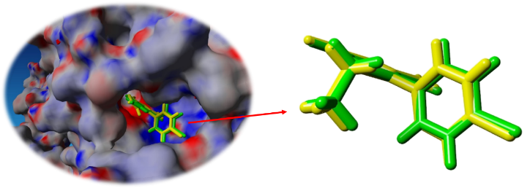
Figure S2. Re-docking the native ligand Pyrimethamine to the active site of PfDHFR-TS receptor.

Table S1. IC₅₀ values of the samples evaluated against the P. falciparum FCR3 variant.
Sample | IC₅₀ (µg/mL) | Categories
EtOAc extract | 1.31±0.82 | Good
MeOH extract | 1.43±0.32 | Good
Chloroquine | 0.003±0.142 | Good

Table S2. Identification of compounds in EtOAc extracts by LC-HRMS analysis.
Compounds |  |  | RT (Min) | Mol Formula | Neutral Mass (DA) | Observed  (m/z) | Adducts | Accuracy
No. | Structure | Name
1 | 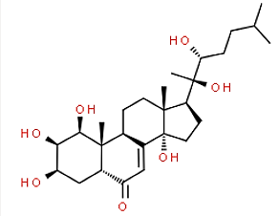 | Zoanthusterone | 6.31 | C₂₇H₄₄O₇ | 480.30870 | 503.2969 | Na⁺ | 3.1229
2 |  | 2R,4S,5S,7S)-5-Amino-N-(3-aminopropyl)-4-hydroxy-7-[4-methoxy-3-(3-methoxypropoxy)benzyl]-2,8-dimethylnonanamide | 8.98 | C₂₆H₄₇N₃O₅ | 481.35157 | 483.3594 | H⁺ | 0.5817

Table S3. Identification of compounds in MeOH extracts by LC-HRMS analysis.
Compounds |  |  | RT  (Min) | Formula | Neutral Mass (DA) | Observed  (m/z) | Adducts | Accuracy
No. | Structure | Name
1 | 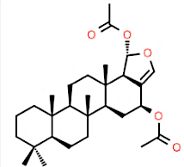 | Hyrtiosin E | 7.79 | C₂₉H₄₄O₅ | 472.31887 | 473.3277 | H⁺ | -1.482
2 | 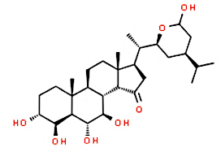 | Contignasterol | 7.61 | C₂₉H₄₈O₇ | 508.34 | 531.3302 | Na⁺ | -0.7869
3 | 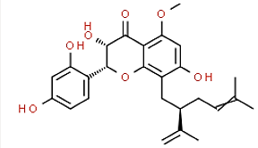 | Kushenol N | 8.23 | C₂₆H₃₀O₇ | 454.19915 | 455.2066 | H⁺ | 1.5411
4 | 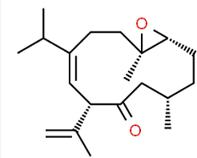 | Calyculone A | 10.32 | C₂₀H₃₂O₂ | 304.24023 | 305.2488 | H⁺ | -1.49881
5 | 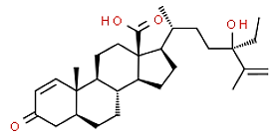 | Norselic Acid B | 11.19 | C₂₉H₄₄O4 | 456.32396 | 479.316 | Na⁺ | -4.8211

