Support Information
Investigation of New 4-Benzyloxy-2-trichloromethylquinazoline Derivatives as Plasmodium falciparum Dihydrofolate Reductase-thymidylate Synthase Inhibitors: QSAR, ADME, Drug-likeness, Toxicity, Molecular Docking and Molecular Dynamics Simulation

Radite Yogaswara^{1,2,3,a)}; Harno Dwi Pranowo^{1,2,b)}*; Niko Prasetyo^{1,2,c)}; Maria Ludya Pulung^{1,4,d)}

¹ Department of Chemistry, Universitas Gadjah Mada, Yogyakarta-55281 (Indonesia)
² Austrian-Indonesian Centre (AIC) for Computational Chemistry, Universitas Gadjah Mada, Yogyakarta-55281 (Indonesia)
³ Department of Chemistry Education, Universitas Papua, Manokwari-98311 (Indonesia)
⁴ Department of Chemistry, Universitas Papua, Manokwari-98311 (Indonesia)

^{a)}r.yogaswara@unipa.ac.id
^{b)}Correspondence: harnodp@ugm.ac.id
^{c)}nikop@ugm.ac.id
^{d)}l.pulung@unipa.ac.id

ORCIDs:
First AUTHOR : https://orcid.org/0000-0002-5937-6200
Second AUTHOR : https://orcid.org/0000-0002-0223-5036
Third AUTHOR : https://orcid.org/0000-0003-0266-7258
Fourth AUTHOR : https://orcid.org/0000-0002-2458-7198

ACKNOWLEDGEMENT

The authors express their gratitude to the Final Project Recognition Grant (RTA) of Universitas Gadjah Mada (5286/UN1.P1/PT.01.03/2024) and the first author thanks the Indonesian Endowment Fund for Education (LPDP), the Ministry of Finance, and the Republic of Indonesia for the scholarship received to pursue their doctoral studies at Gadjah Mada University (2022–2026). The authors acknowledge the Cresset Discovery Group for providing Spark free licenses.

AUTHOR CONTRIBUTIONS

Conceptualization, R. Y.and H. D. P.; Methodology, N. P.; Software, Resources and Visualization, M. L. P.; Supervision and Validation, H. D. P. and N. P.; Formal Analysis, Investigation, Data Curation, and Writing – Original Draft Preparation, R. Y.; Writing – Review & Editing, All authors.

CONFLICT OF INTEREST

No conflict of interest exists, according to the authors.

DECLARATION OF GENERATIVE AI AND AI-ASSISTED
TECHNOLOGIES IN THE MANUSCRIPT PREPARATION

Not applicable.

Figure S1. Template structure of 4-benzyloxy-2-trichloromethylquinazoline.

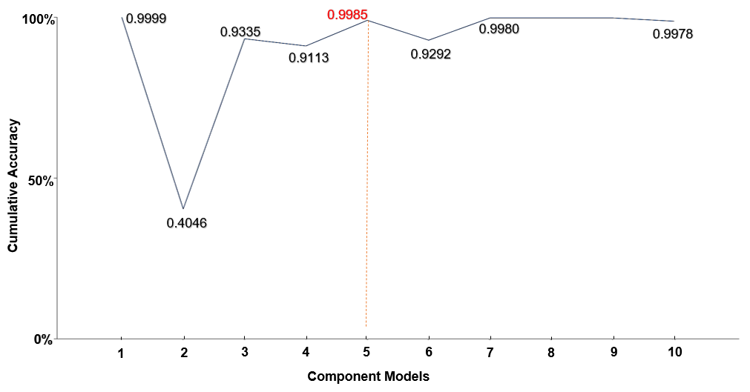
Figure S2. Ensemble the accuracy sum of descriptors for the best model.

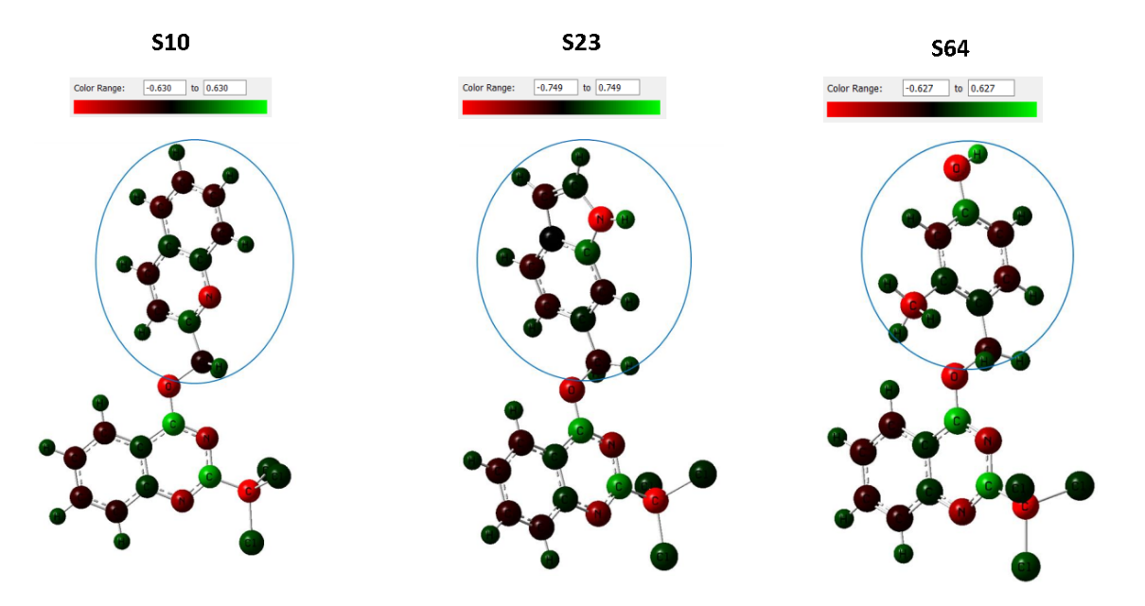
Figure S3. Analysis of the electron density function of molecules (a) S10, (b) S23 and (c) S64.
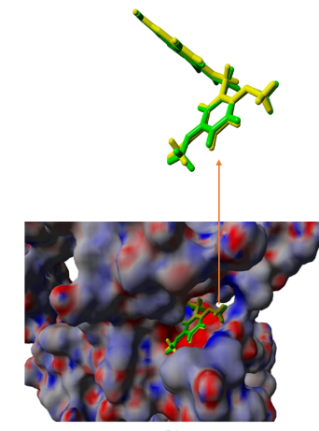
Figure S4. Re-docking KA5-3JSU whereas the native ligand, based on the experimental evidence, is yellow and the green color is the native ligand after re-docking.

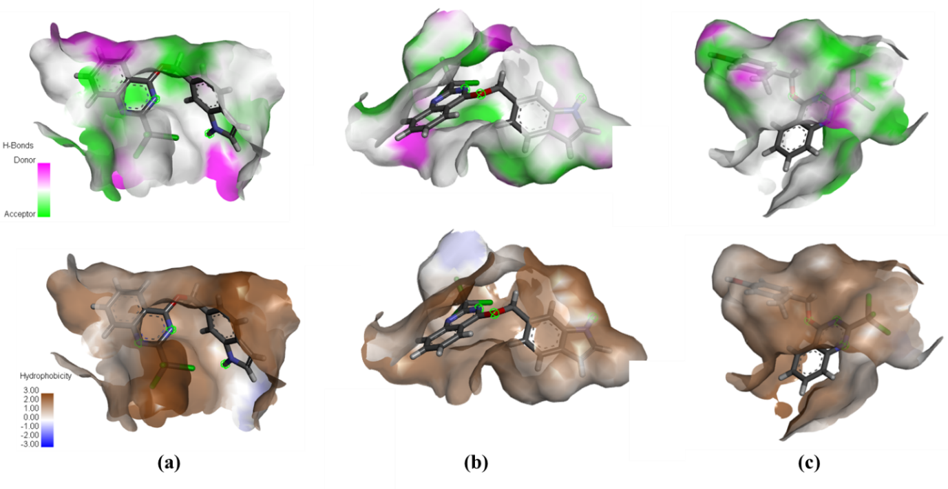
Figure S5. The 3D docking poses H-bond and hydrophobicity contours of (a) S10, (b) S23, and (c) S64 in the QM-PfDHFR-TS (3JSU) binding pocket.

Table S1. ¹H-NMR chemical shift calculation

Position | δ Experiment (ppm) | B3LYP/3-21G | B3LYP/6-31G | B3LYP/6-311G | B3LYP/6-31G+ | B3LYP/6-31G++ | B3LYP/6-311G+ | B3LYP/6-311G++
H-8 | 8.23 | 7.12 | 7.49 | 7.47 | 7.24 | 7.58 | 7.54 | 8.59
H-9 | 7.88 | 7.31 | 7.72 | 7.72 | 7.52 | 7.90 | 7.85 | 8.81
H-10 | 8.07 | 7.62 | 8.07 | 7.98 | 7.88 | 8.32 | 8.20 | 9.02
H-11 | 7.88 | 6.95 | 7.33 | 7.32 | 6.89 | 7.22 | 7.19 | 8.35
PRESS |  | 2.63 | 0.87 | 0.92 | 2.13 | 0.92 | 0.97 | 2.11

Table S2. Selected descriptors with AlvaDesc
Descriptor Code | Contribution to increased activity | Class | Description
ATS6m | Negative | 2D autocorrelations | Broto-Moreau autocorrelation of lag 6 (log function) weighted by mass
ATSC7m | Negative | 2D autocorrelations | Centered Broto-Moreau autocorrelation of lag 7 weighted by mass
GATS4e | Positive | 2D autocorrelations | Geary autocorrelation of lag 4 weighted by Sanderson electronegativity
SpMax_AEA(ed) | Positive | Edge adjacency indices | Leading eigenvalue from augmented edge adjacency mat. weighted by edge degree
Mor28e | Positive | 3D-MoRSE descriptors | Signal 28 / weighted by Sanderson electronegativity

Table S3. Computed model descriptors and predicted activity using 2D-QSAR models
Molecules | Y_{(obs)}  pIC₅₀ | ATS6m | ATSC7m | GATS4e | SpMax_AEA  (ed) | Mor28e | Y_{(calc)}  MLR | Residual | Y_{(calc)}  PLS | Residual
C1* | 5.699 | 3.8691 | 26.0905 | 1.1515 | 7.1312 | -0.5297 | 5.70 | -0.001 | 5.68 | 0.019
C2 | 5.398 | 3.9025 | 30.9848 | 1.0438 | 7.1312 | -0.6254 | 5.43 | -0.032 | 5.44 | -0.042
C4 | 5.602 | 3.9551 | 25.3302 | 1.1782 | 7.1312 | -0.4887 | 5.58 | 0.022 | 5.57 | 0.032
C5 | 5.745 | 3.9548 | 27.1807 | 1.2159 | 7.1312 | -0.2611 | 5.73 | 0.015 | 5.74 | 0.005
C6 | 5.658 | 3.9741 | 25.4577 | 1.2055 | 7.1312 | -0.2547 | 5.72 | -0.062 | 5.73 | -0.072
C7 | 5.638 | 3.9728 | 25.6994 | 1.1717 | 7.1312 | -0.4426 | 5.60 | 0.038 | 5.59 | 0.048
C8 | 5.553 | 3.9893 | 29.2176 | 1.1804 | 7.1312 | -0.3757 | 5.62 | -0.067 | 5.62 | -0.067
C10 | 5.409 | 4.0060 | 38.4741 | 1.1115 | 7.1312 | -0.6808 | 5.35 | 0.059 | 5.36 | 0.049
C11* | 5.481 | 3.9688 | 26.8034 | 1.0747 | 7.1314 | -0.5671 | 5.53 | -0.049 | 5.51 | -0.029
C12* | 5.456 | 4.0918 | 28.1770 | 1.0943 | 7.1314 | -0.5584 | 5.49 | -0.034 | 5.46 | -0.004
C13 | 5.377 | 4.1906 | 27.0362 | 1.0374 | 7.1314 | -0.6497 | 5.39 | -0.013 | 5.40 | -0.023
C14 | 5.620 | 4.0451 | 26.7961 | 1.2252 | 7.1315 | -0.6485 | 5.62 | 0 | 5.63 | -0.010
C15* | 5.824 | 4.0383 | 20.2606 | 1.1352 | 7.1315 | -0.4554 | 5.82 | 0.004 | 5.85 | -0.026
C16 | 5.509 | 4.1606 | 30.4268 | 1.0990 | 7.1312 | -0.3687 | 5.49 | 0.019 | 5.47 | 0.039
C17 | 5.585 | 3.9504 | 30.8655 | 1.1078 | 7.1312 | -0.3784 | 5.59 | -0.005 | 5.60 | -0.015
C18 | 5.420 | 4.1452 | 35.6299 | 1.1959 | 7.1312 | -0.5097 | 5.44 | -0.020 | 5.43 | -0.010
C19 | 5.745 | 4.0097 | 21.1913 | 1.2469 | 7.1314 | -0.4099 | 5.76 | -0.015 | 5.76 | -0.015
C20 | 5.638 | 4.1398 | 22.5953 | 1.1228 | 7.1314 | -0.4063 | 5.62 | 0.018 | 5.61 | 0.028
C21 | 5.721 | 4.2234 | 27.3728 | 1.2651 | 7.1315 | -0.3456 | 5.72 | 0.001 | 5.73 | -0.009
C22 | 5.796 | 3.9324 | 13.2896 | 1.2182 | 7.1314 | -0.3774 | 5.84 | -0.044 | 5.83 | -0.034
C23 | 5.638 | 3.9680 | 16.3655 | 1.1439 | 7.1314 | -0.5952 | 5.64 | -0.002 | 5.62 | 0.018
C24 | 5.770 | 3.9831 | 17.7685 | 1.1204 | 7.1314 | -0.4128 | 5.72 | 0.050 | 5.71 | 0.060
C25 | 5.824 | 4.0449 | 17.5771 | 1.1186 | 7.1315 | -0.3434 | 5.78 | 0.044 | 5.79 | 0.034
C26 | 5.721 | 3.9695 | 17.7807 | 0.9599 | 7.1314 | -0.3250 | 5.69 | 0.031 | 5.70 | 0.021
C28 | 5.357 | 4.1826 | 18.7305 | 0.7434 | 7.1317 | -0.7137 | 5.39 | -0.033 | 5.39 | -0.033
C30* | 6.046 | 3.9832 | 14.2007 | 1.2317 | 7.1314 | -0.3782 | 6.05 | -0.004 | 6.02 | 0.026
C31* | 5.921 | 4.0949 | 20.3657 | 1.2188 | 7.1315 | -0.2776 | 5.92 | 0.001 | 5.89 | 0.031

Table S4. Design of novel molecules from 4-benzyloxy-2-trichloromethylquinazoline derivatives and their predicted activities (pIC₅₀ and IC₅₀) values
Molecule ID | R | pIC₅₀ prediction (µM) | IC₅₀ prediction (µM) | Molecule ID | R | pIC₅₀ prediction (µM) | IC₅₀ prediction (µM)
S2 | 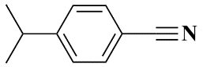 | 5.577 | 2.648 | S24 | 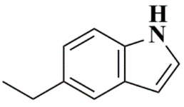 | 5.571 | 2.687
S3 | 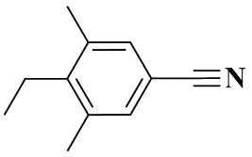 | 5.479 | 3.317 | S25 | 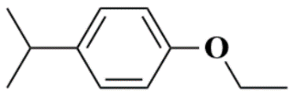 | 5.446 | 3.585
S4 | 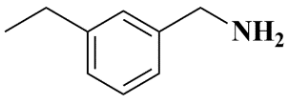 | 5.539 | 2.893 | S27 | 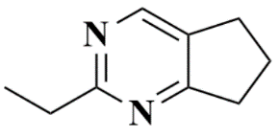 | 5.398 | 4.004
S10 | 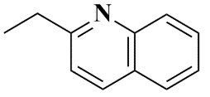 | 5.765 | 1.718 | S30 | 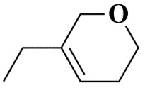 | 5.553 | 2.796
S11 | 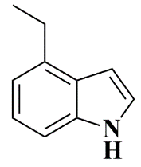 | 5.441 | 3.620 | S37 | 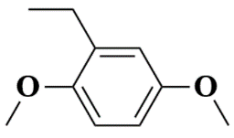 | 5.444 | 3.596
S13 | 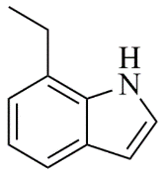 | 5.573 | 2.674 | S41 | 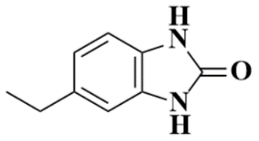 | 5.568 | 2.703
S14 | 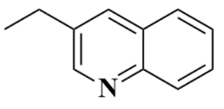 | 5.532 | 2.936 | S49 | 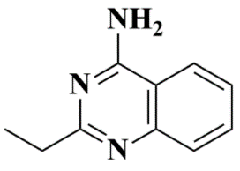 | 5.388 | 4.093
S15 | 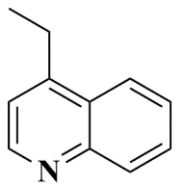 | 5.545 | 2.852 | S52 | 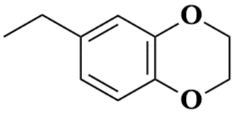 | 5.498 | 3.179
S17 | 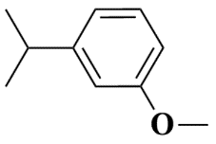 | 5.439 | 3.637 | S53 | 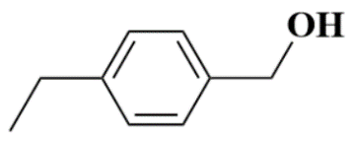 | 5.459 | 3.475
S18 | 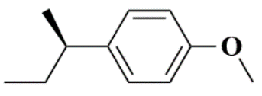 | 5.471 | 3.380 | S57 | 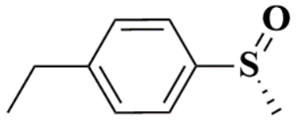 | 5.537 | 2.901
S21 | 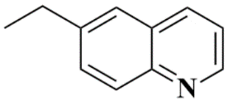 | 5.482 | 3.294 | S61 | 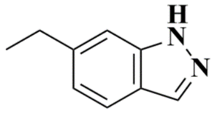 | 5.583 | 2.614
S22 | 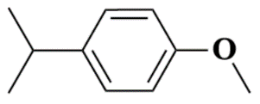 | 5.525 | 2.984 | S64 | 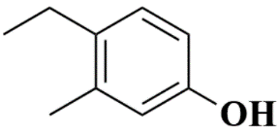 | 5.786 | 1.636
S23 | 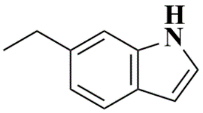 | 5.822 | 1.506 | S74 | 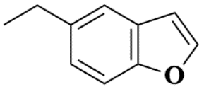 | 5.554 | 2.793

Table S5. The inhibition constant (K_{i}) on DHFR enzymes of P. falciparum Wild type (WT-PfDHFR) and quadruple mutant (QM-PfDHFR) and human (hDHFR) against Cycloguanil, Pyrimethamine, WR99210, KA5 [6], [87], S10, S23, and S64.
Ligand | Mean K_{i} (nM) ± SD |  |  | K_{i} ratio
Ligand | WT-PfDHFR | QM-PfDHFR | hDHFR | hDHFR/ WT-PfDHFR | QM-PfDHFR/ WT-PfDHFR
Cycloguanil | 1.51 ± 0.10 | 454.00 ± 38.00 | 55.6 ± 7.8 | 37.00 | 300.00
Pyrimethamine | 0.59 ± 0.05 | 385.00 ± 163.00 | 30.8 ± 1.4 | 52.00 | 652.00
WR99210 | 0.50 ± 0.10 | 1.90 ± 0.80 | 7.7 ± 0.4 | 15.00 | 1.80
KA5 | 0.39 ± 0.05 | 0.58 ± 0.06 | 10.2 ± 0.6 | 26.00 | 1.50
S10 | 0.46 ± 0.08 | 45.99 ± 66.39 | 10.2 ± 0.6 | 22.17 | 99.98
S23 | 0.44 ± 0.41 | 144.90 ± 67.48 | 10.2 ± 0.6 | 23.18 | 329.32
S64 | 0.30 ± 0.39 | 261.59 ± 68.40 | 10.2 ± 0.6 | 34.00 | 871.97

